# What is computer

Computer is an electronic device that take some input and process and give some meaning full output.

# What is 0 and 1?

There is nothing like 0 and 1 in computer.there is no physical significance of 0 and 1.

Any information can be encoded as a sequence of 0 and 1.

When the north pole is make on the up, so we can say it 0 and if north pole is make on the down, so we can say 1.

# What is hardware?

Hardware is anything which is tangible.

Hardware is all physical part of computer, as distinguished from the data it contain or operates on and the software that provide instruction for the hardware to accomplish tasks.

# Program and process

Set of instruction is called program.

Active state of a program is called process.

# Operating system

It is a system software.

It provide interface between user and machine.

Acts as a manager of the computer system.

It does process management, memory management, file management.

Ex:-

Ms DOS, window 7,8,10 etc.

Ubuntu linux.

# Execution of a program

When we want to run the application or file and file or data are store in the hard disk hen file suddenly file converted in 0and1 form then file make a copy of this file and past on the ram and then 16 0and1 are placed on CPU on MU(memory unit) and suddenly MU and the send the instruction to the CU(control unit) then control unit understand the whole work and instruction then CU send the instruction to the ALU(arithmetical logical unit) then ALU doing the whole work.

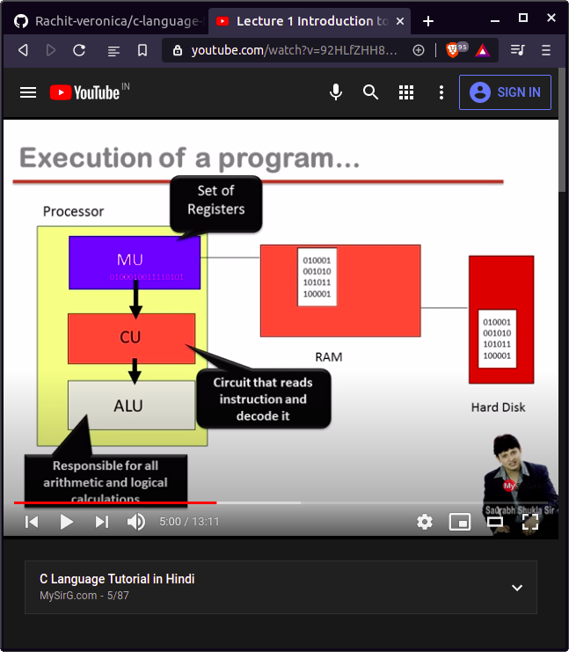

# Software development in c

When we want to make a exe file so, can user there step:-

1. Firstly we make source file and it have a extention is .c(because we make a file in c language).
2. Then the file is going to the preprocessor. Preprocessor it handel the keyword who it start from(#). then preprocessor is mix the source file and header file and then make some special file the do not show it harder file. It has a extention is (.i).
3. then the special file (.i) is coming in the compiler. The compiler is a translater that convert extention (.i) into (.obj).
4. Then we can use linker to link the (.obj) and library file (library is like a disnary that every keyword meaning are store in the library files) and then convert into .exe file.

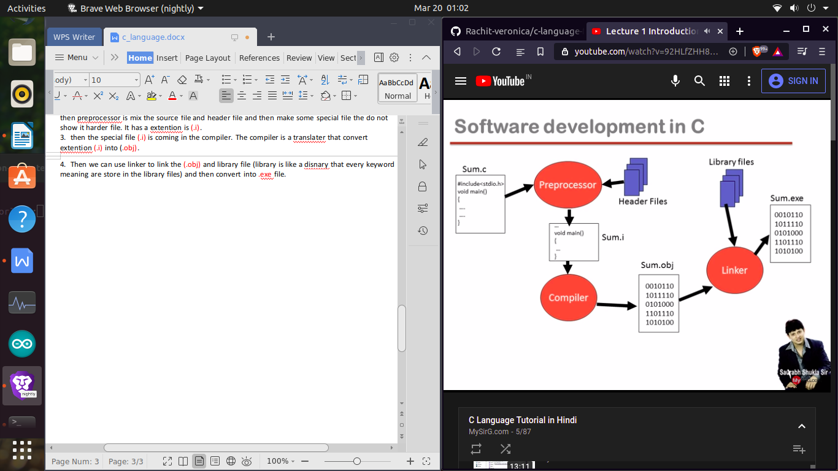

# Begin learning c

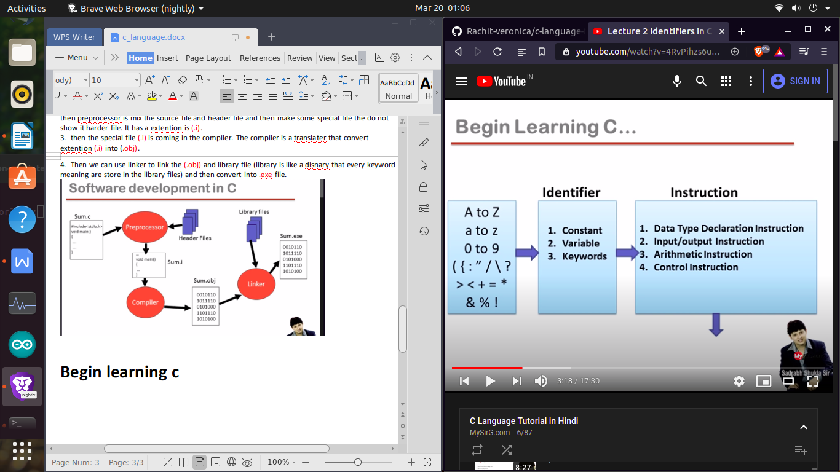

Constant

Any information is constant

Data=information=constant

There are two type of constant:-

1. Primary 2> secondary
2. Interger 1> array
3. Real 2> string
4. character 3> pointer
5. Union
6. Structure
7. enumerator
8. Integer

Integer is who number which do not have any decimal and character.

Ex:- -55 , 34.45

1. Real   
   real is who number which have decimal

Ex:- 21.4,32.3,45.3

1. Character

Character which only single word,number or special char but in it in single cote.

Ex:- ‘a’,’A’,’+’,’ ’,’2’.

Secondary constant

Secondary constant is totally depend on primary constant.

# Keyword

Predefined word

Reserved word

There are 32 keyword in c language in 16 bit architecture.

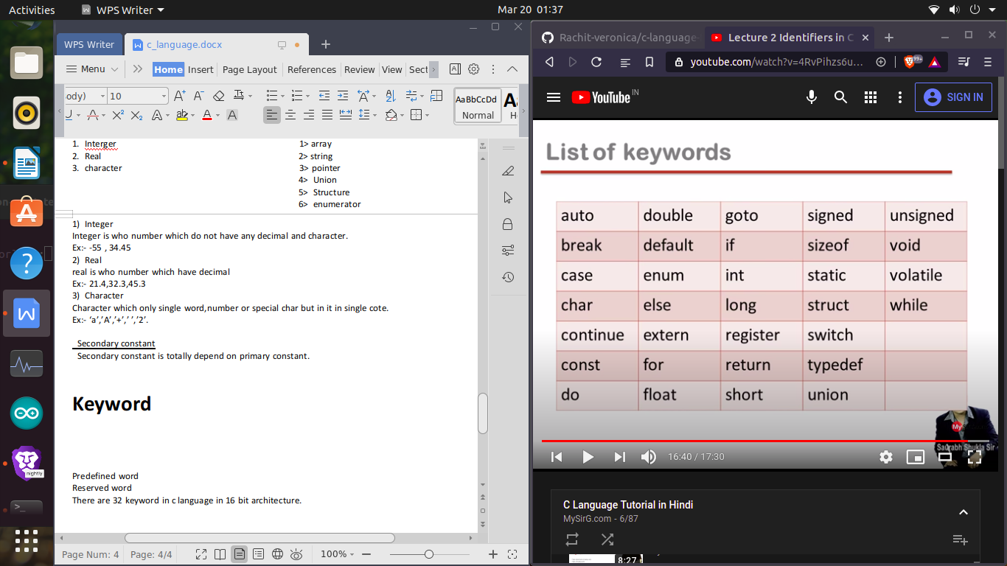

# Instruction

Program statements are call instruction

Instruction are commands

Type of instruction

1. Data type declaration instruction.
2. Input output instruction.
3. Arithmetic instruction.
4. Control instruction.

# Data type

1. Int
2. Char
3. Float
4. Double
5. Void

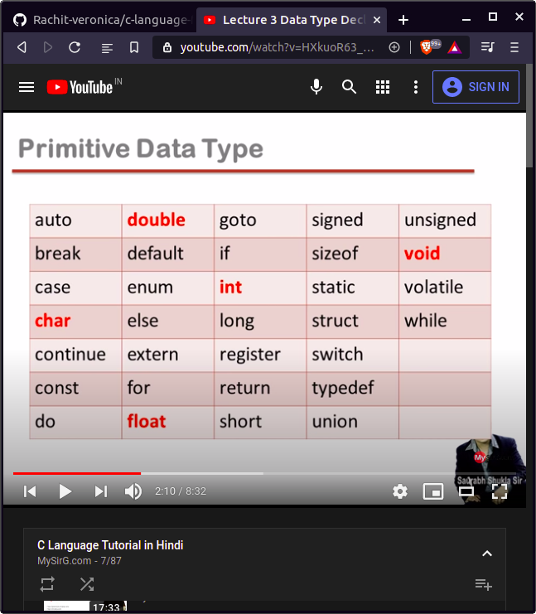

# Declaration statement

1. Int memory only store Integer constant.
2. Float only store Real constant.
3. Char only store Character constant.

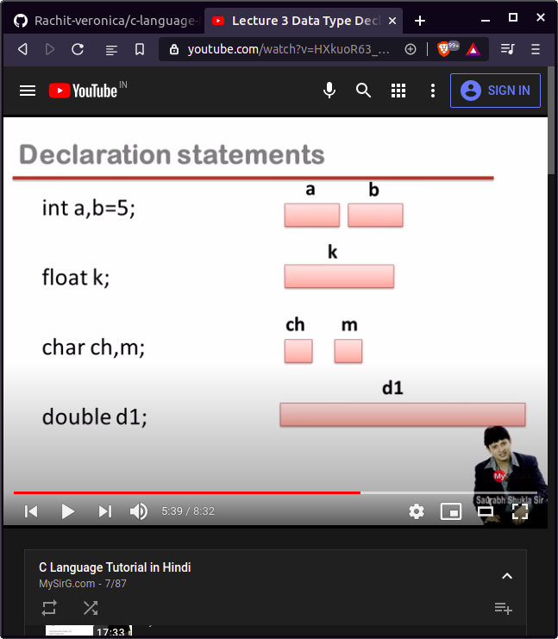

Data type consume size:-

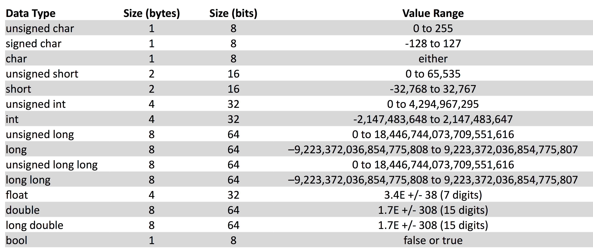

Printf

Printf is not a keyword

Printf is a predefined function

Printf is use to print any line or sentences etc.

Note:- when we wright any name or sentences in double codes, so it is make a string. String is combination single word is called string.

program

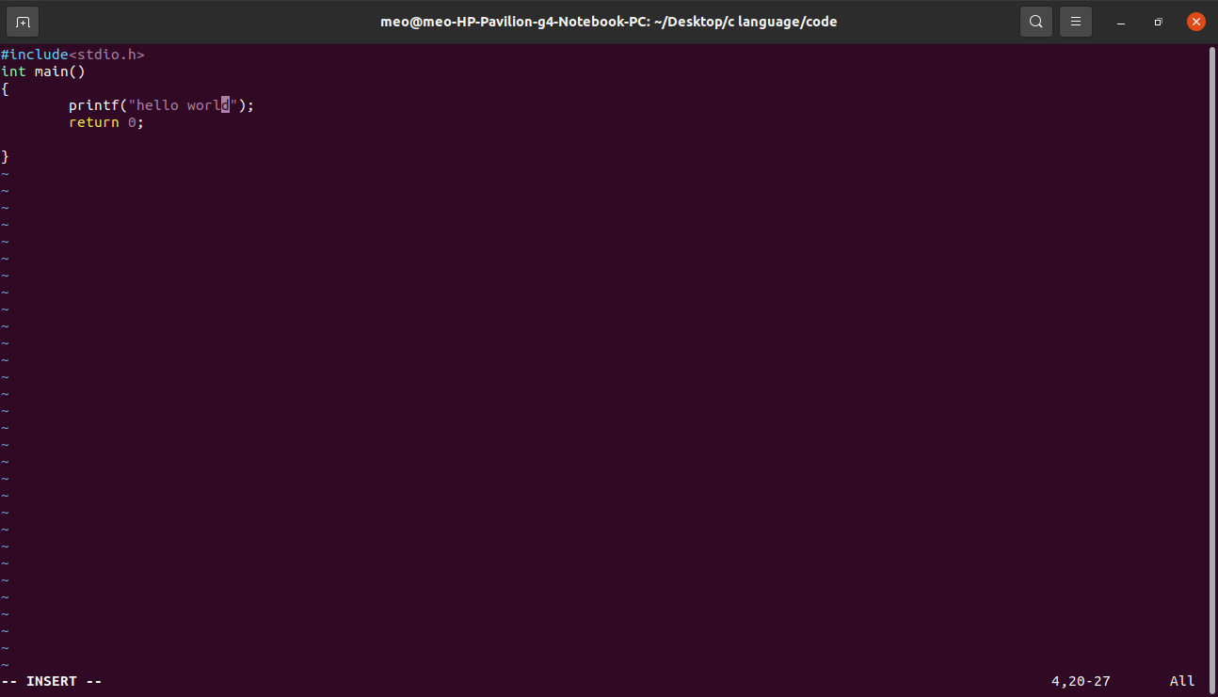

output

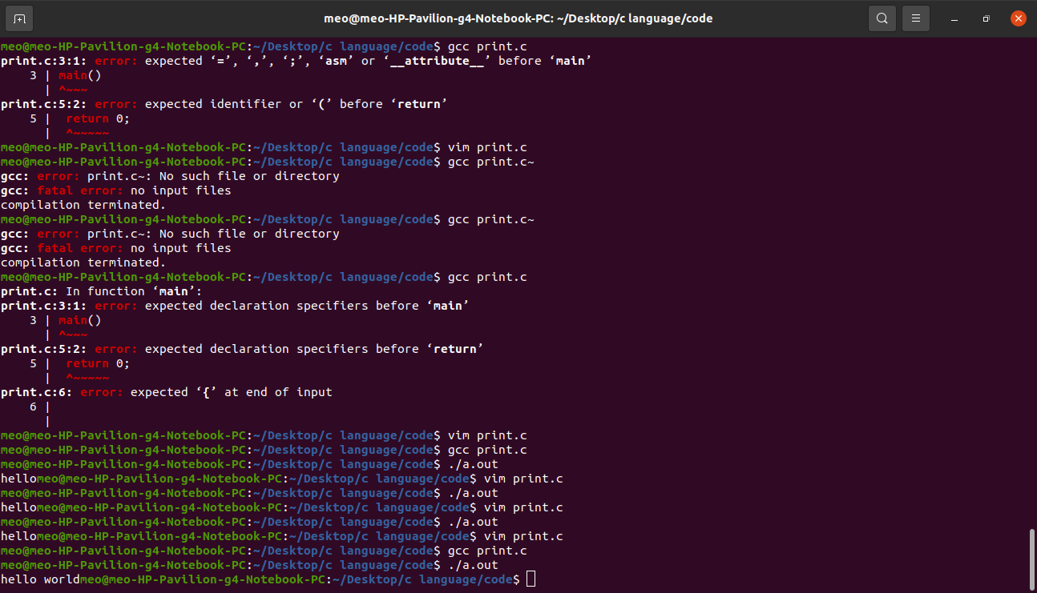

We print the line thorough( \n)

program

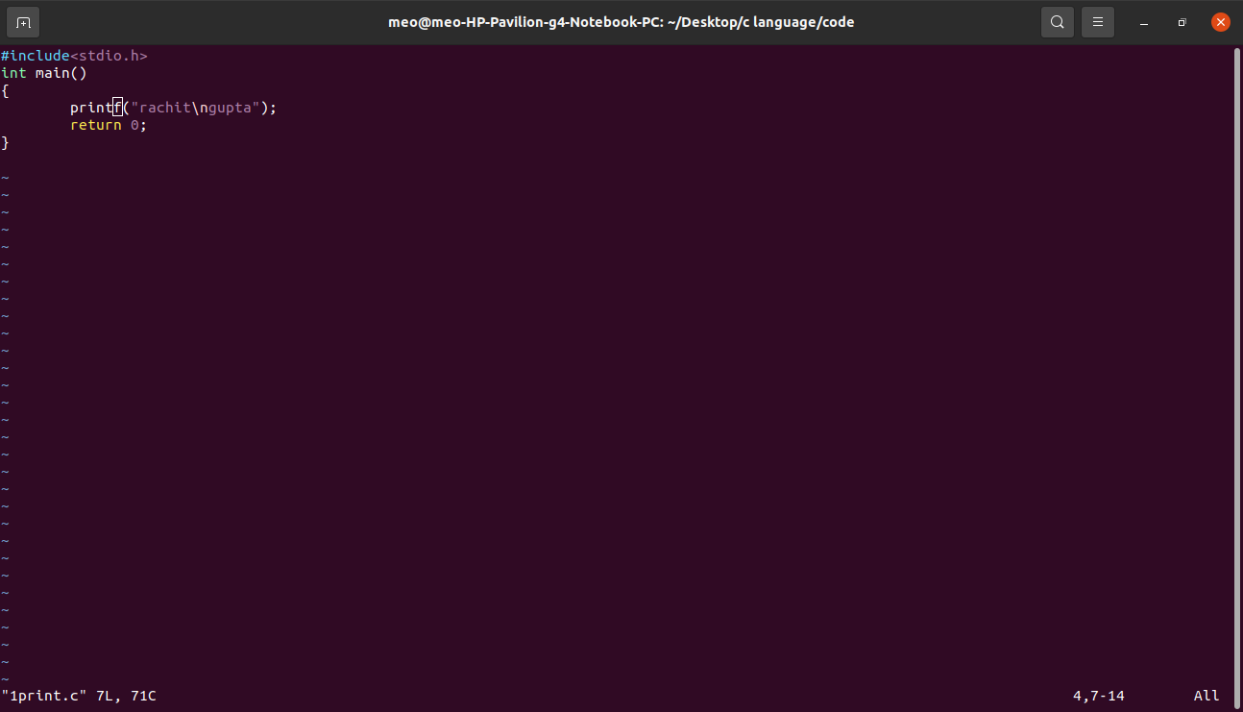

Output

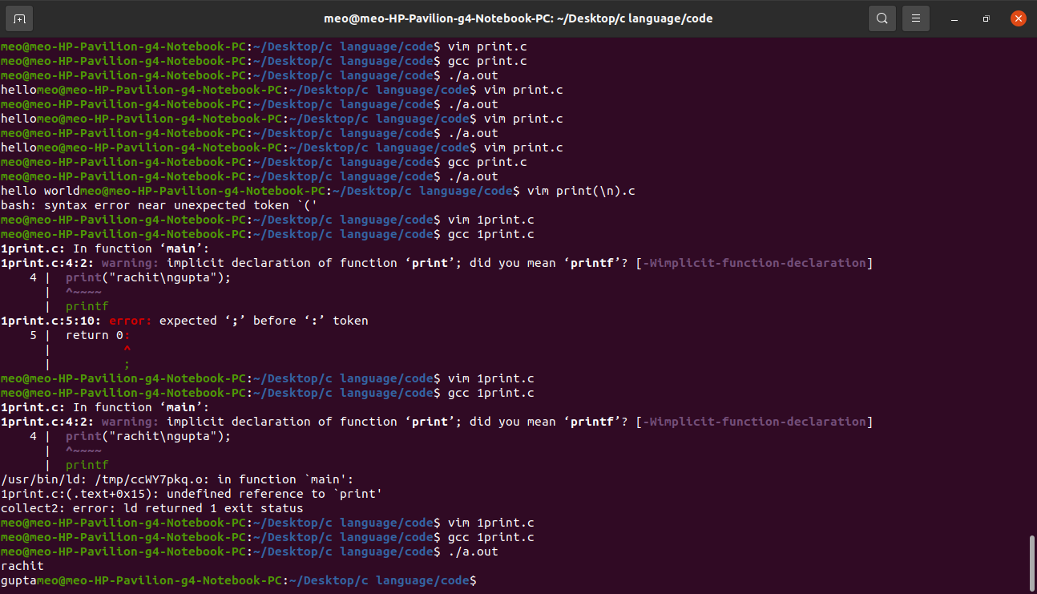

We print a line in the center with use (gotoxy())

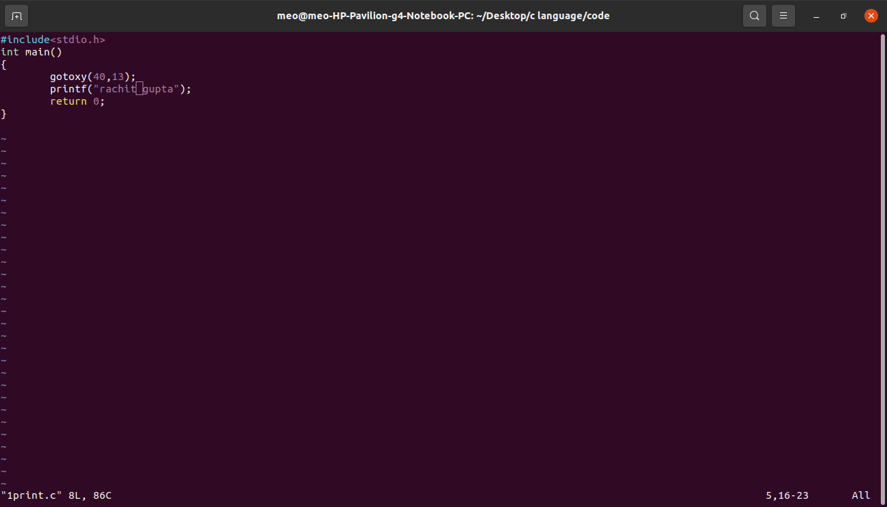

Space between two word with the help of (\t)

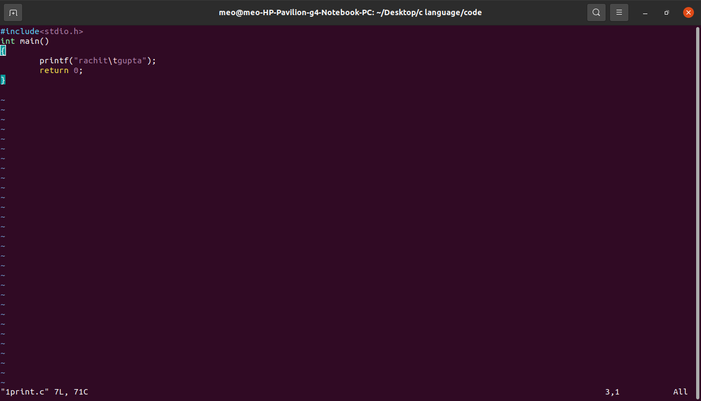

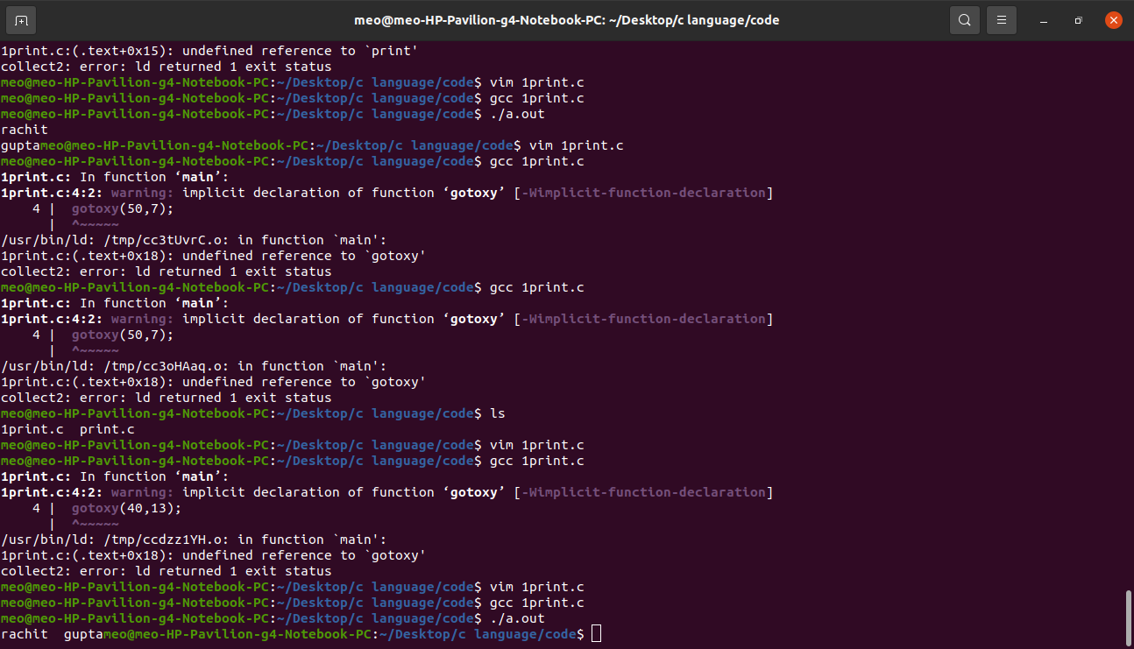

We earse the last word and also remove the space between two word

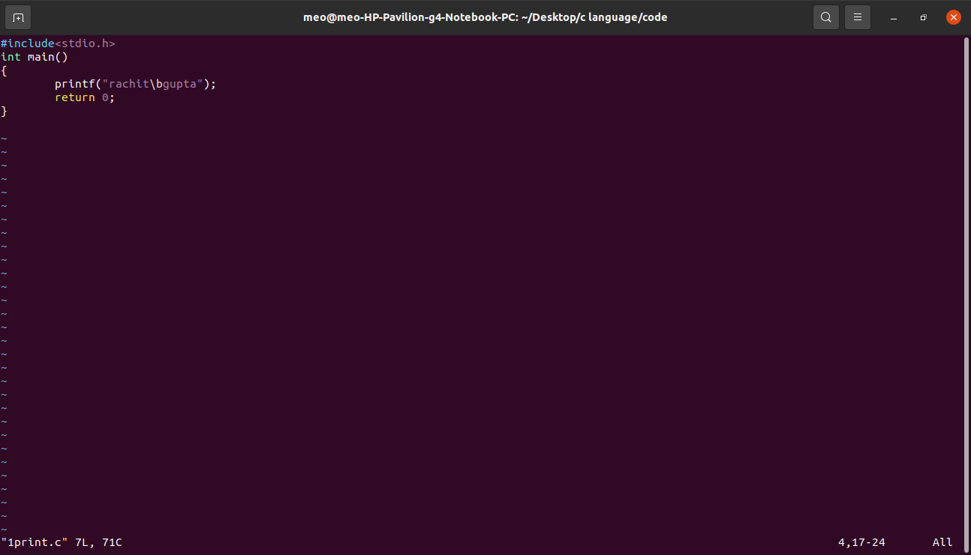

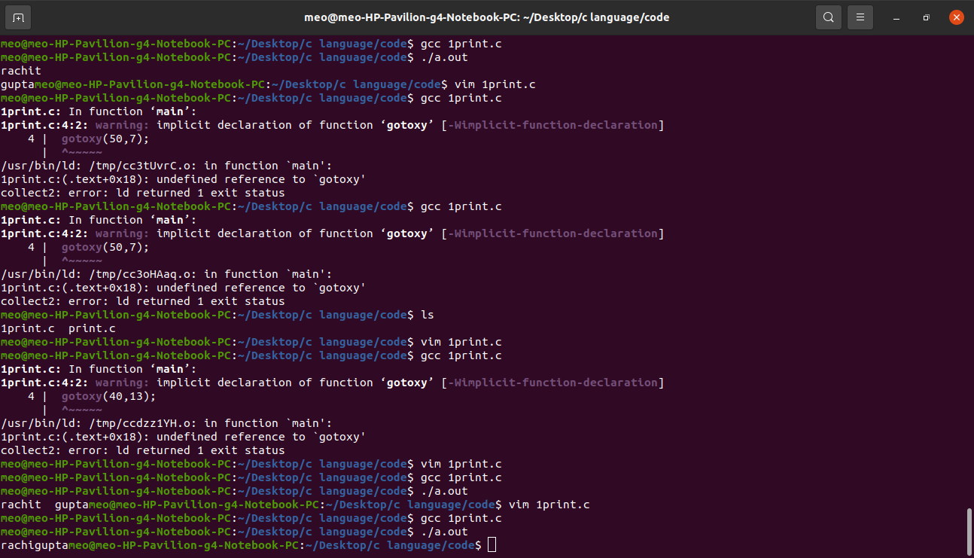

We wright (\) between two word

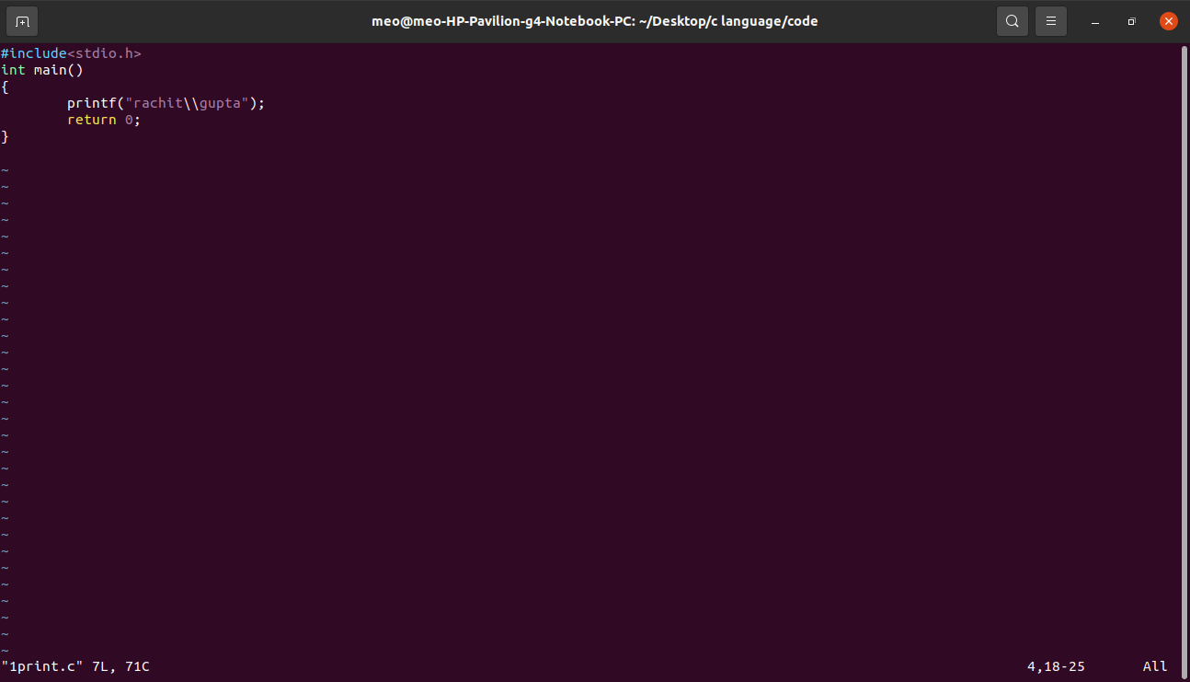

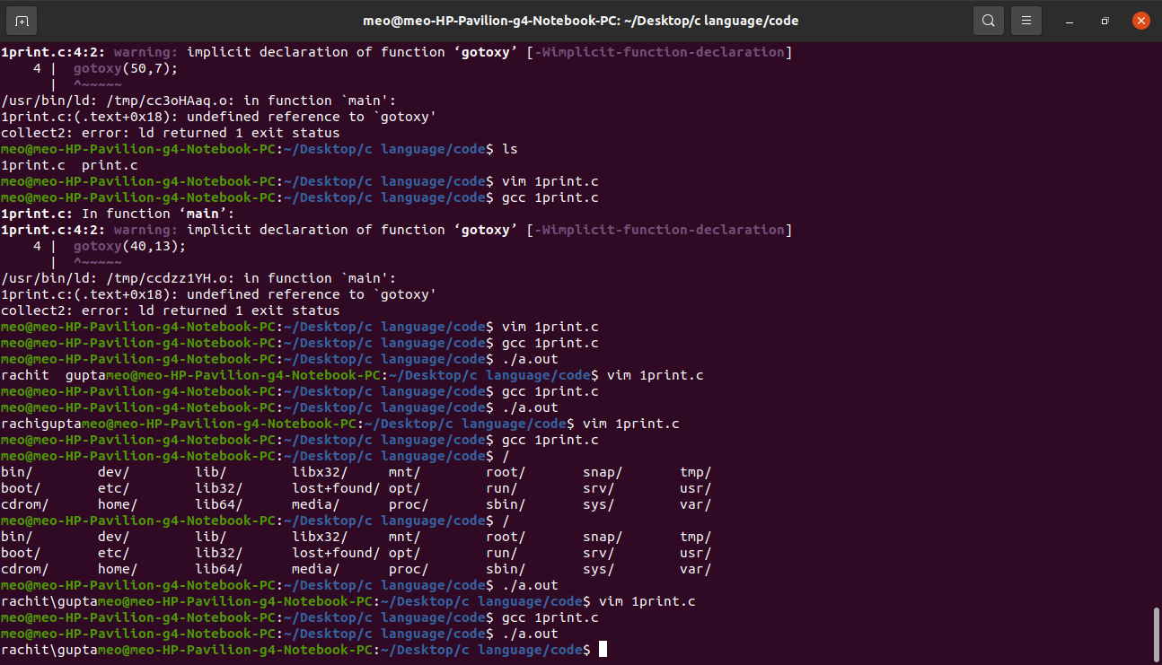

We make double codes between two word.

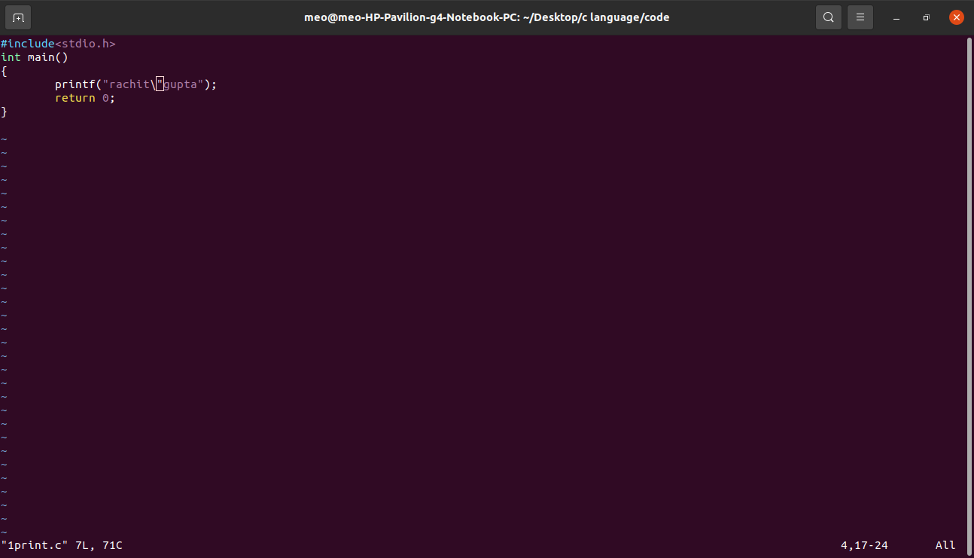

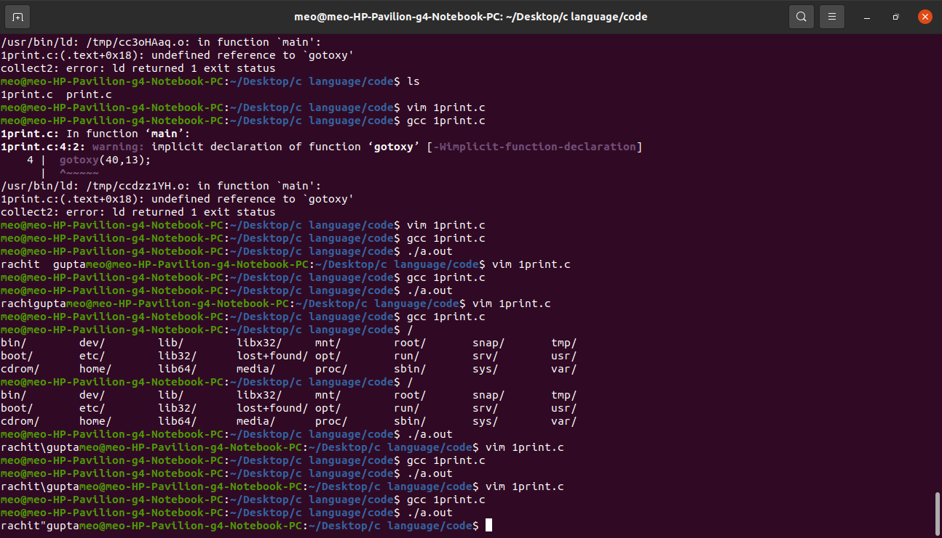

We remove first word between two word

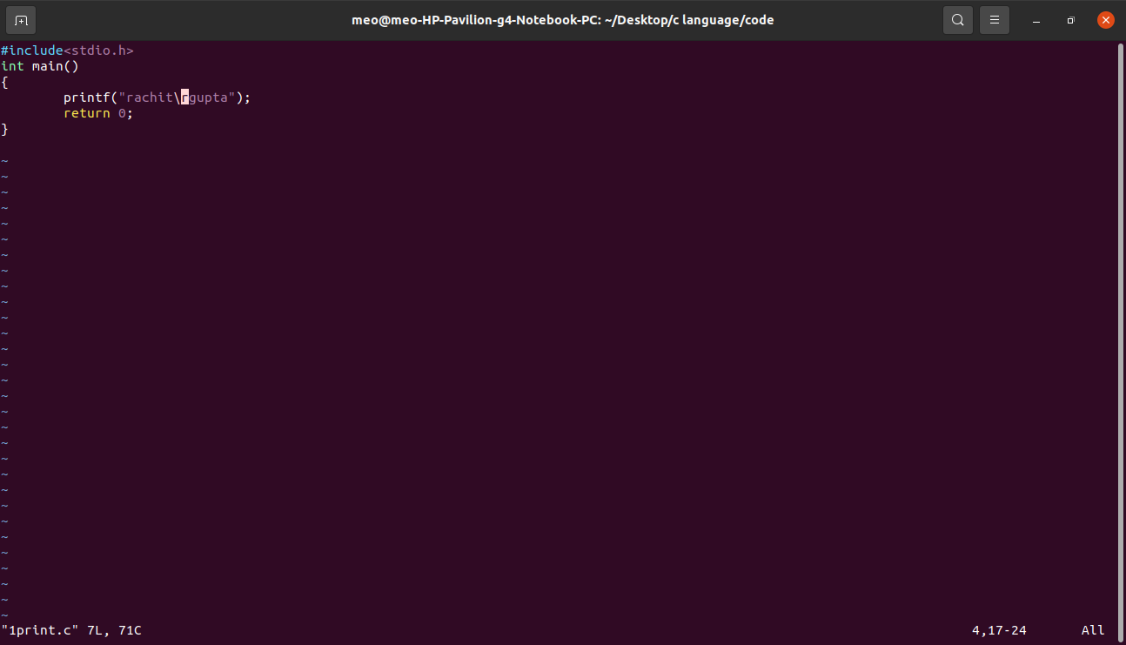

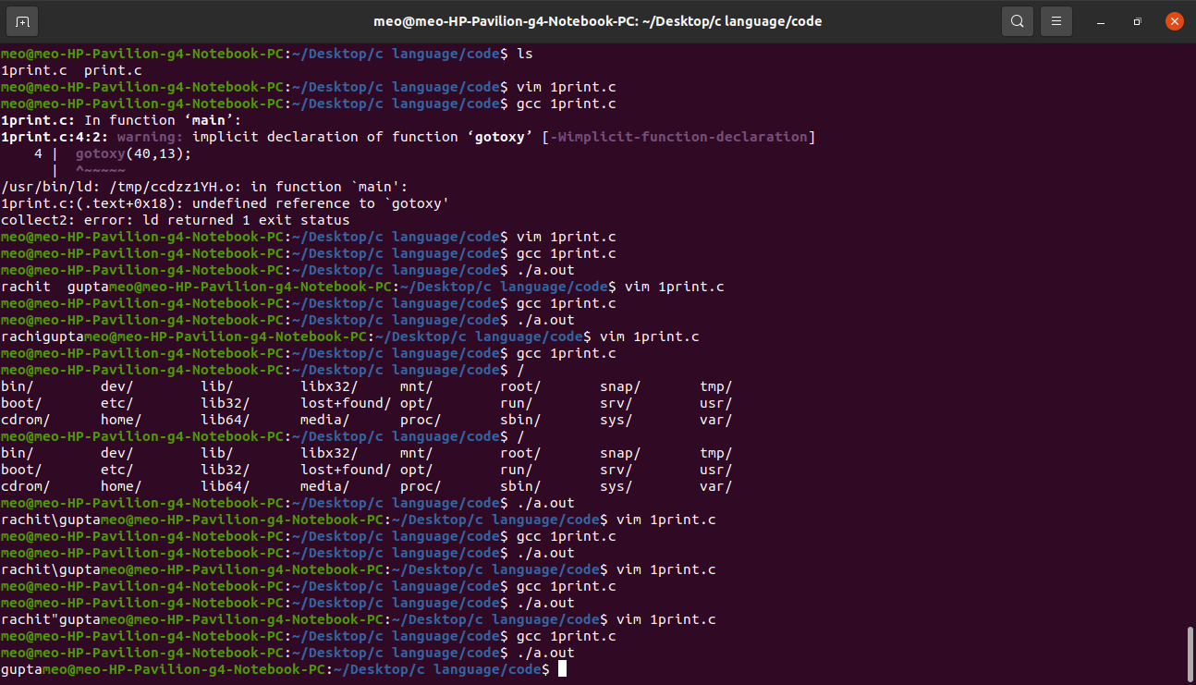

We want to print the value of any variable, so can you there program.

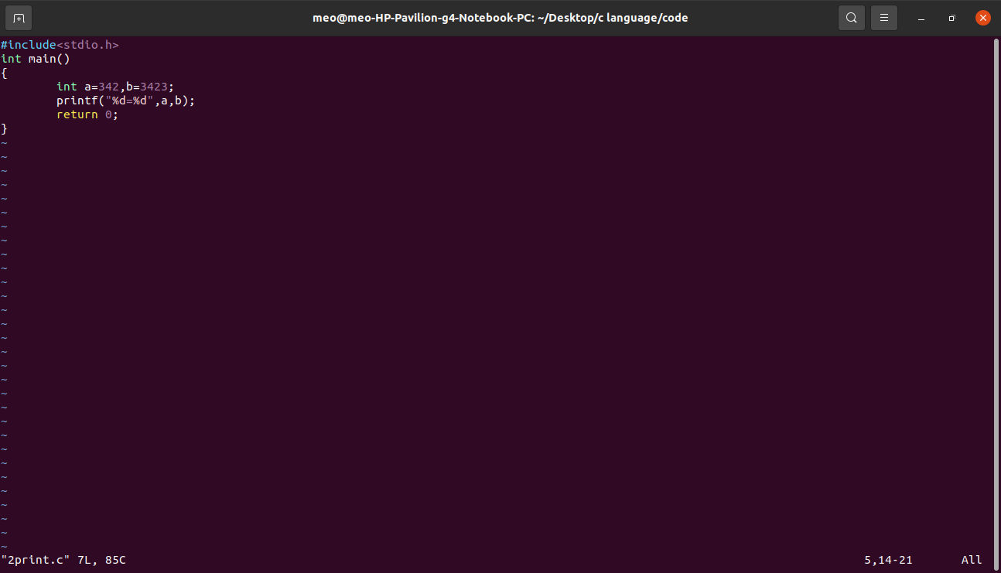  
  
Answer

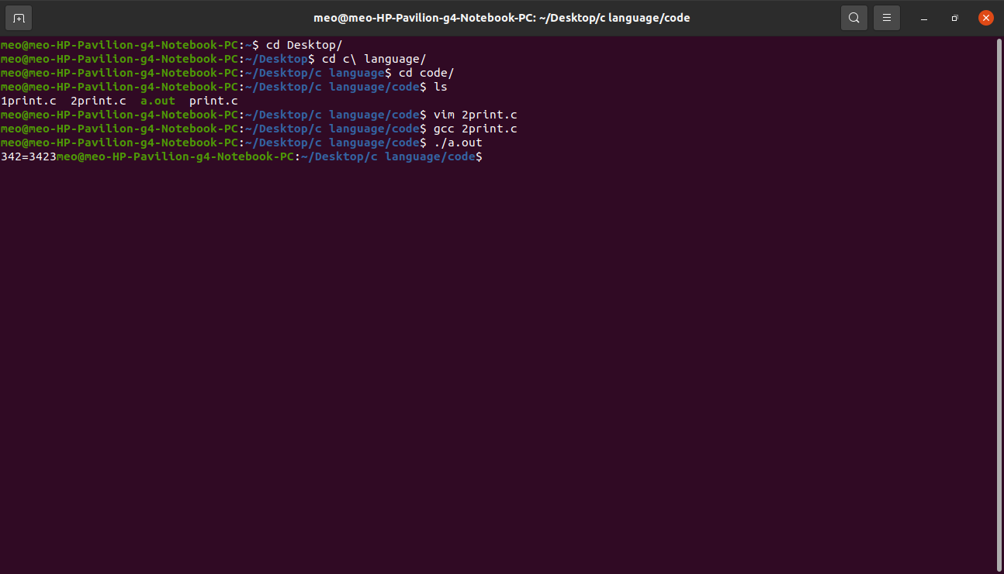  
  
when we want to (+),(-),(*) etc so, we can use these program :-

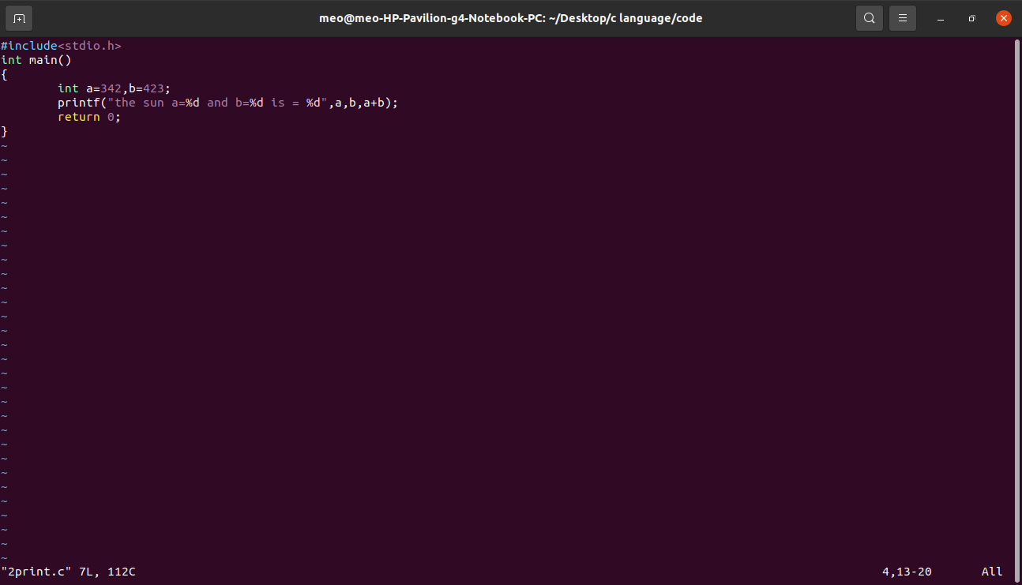  
  
Answer:-

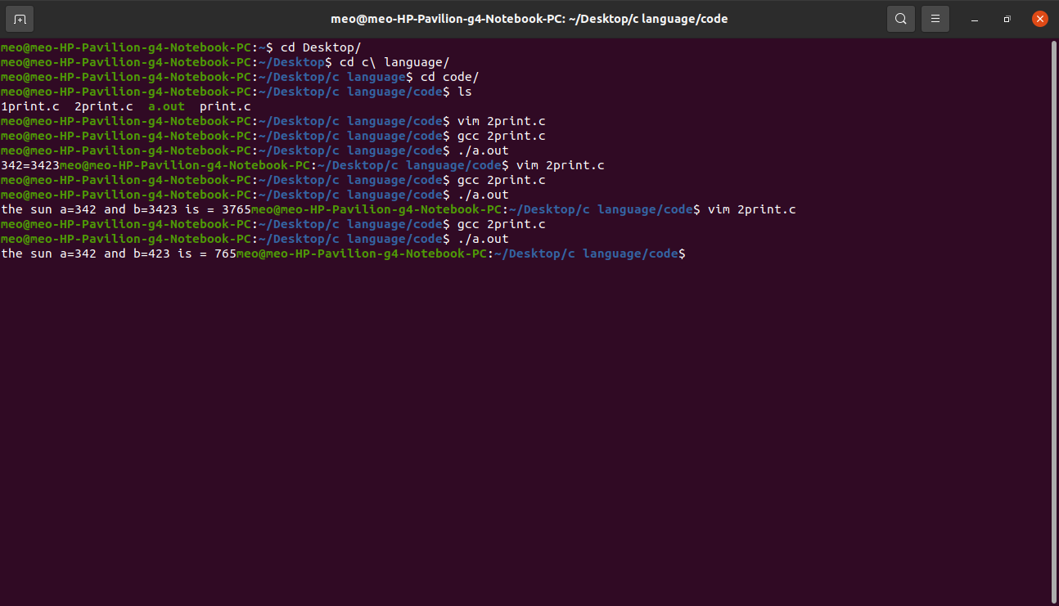  
  
 when we use to more format specifier :-  
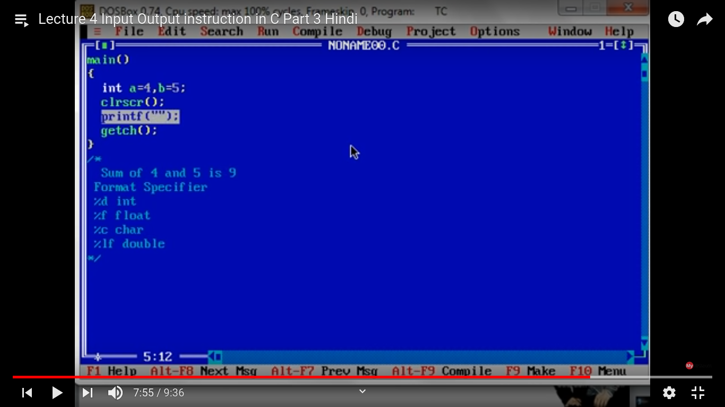  
  
Scanf()  
  
scanf() is not a keyword

Scanf() is a predefined function

We can use scanf() to take the value as a input through user.

Scanf(“format specifier”,variable address);

There are three work of scanf() :-

1. He take a input to the user.
2. Then it print the number that he take the input to the user.
3. And lastly he store the value in the variable.

We want to add two number with using scanf() and take input to the user.

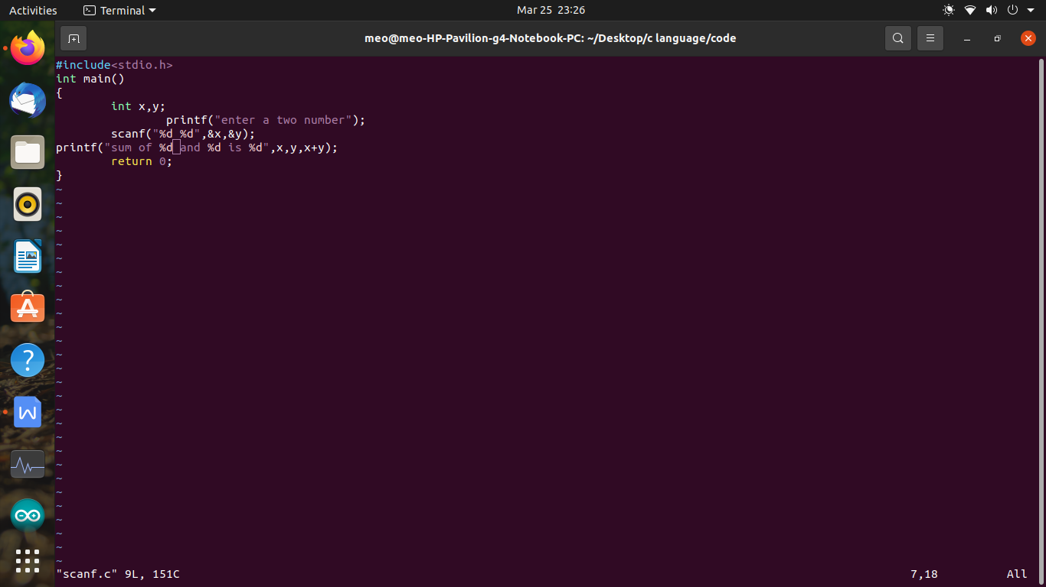  
  
Answer  
  
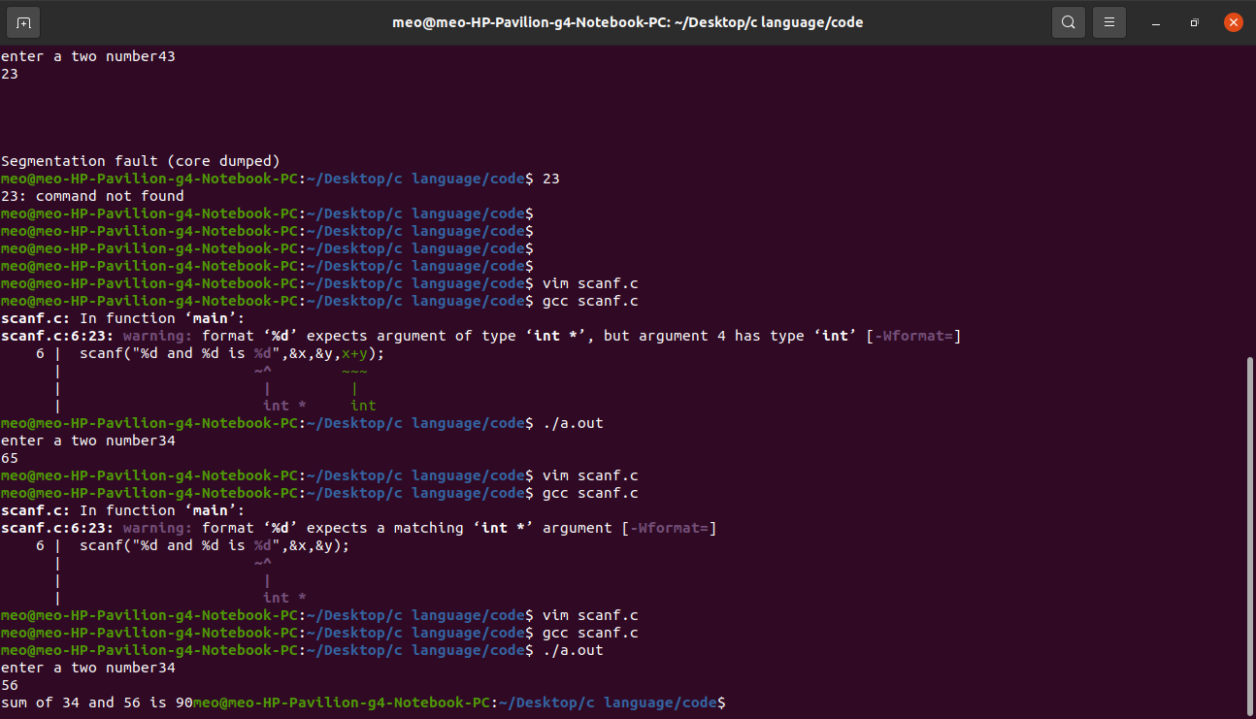

# Gotoxy

Gotoxy is use to to move the curser in whole screen with the using of there ratio (H,V) (80,25)

In the gcc compiler gotoxy fuction is not working so we skip this function.

Ascii codes  
  
  
ascll codes is American Standard Code for Infromation Interchange.  
  
ascii is a coding technic that we already store the code (value) of any variable.  
  
There are 256 ascii codes  
  
128+128 that it is divide into to part.  
  
Ascii code is start from 0 to 127 and 128 to 255.

Ascii code definition   
  
ascii code is the numerical representation of a character such as ‘a’ or ‘@’ or an action of some sort.  
  
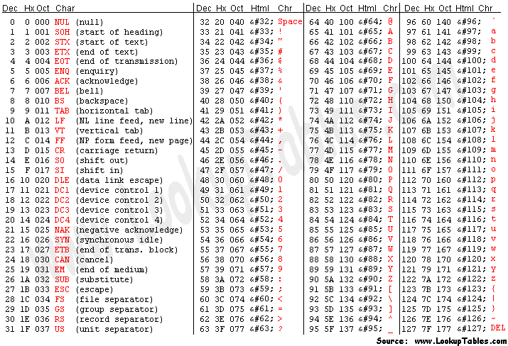  
  
Arithmetic Instruction   
  
An instruction which is used to manipulate data using operators, is known as Arithmetic Instruction  
  
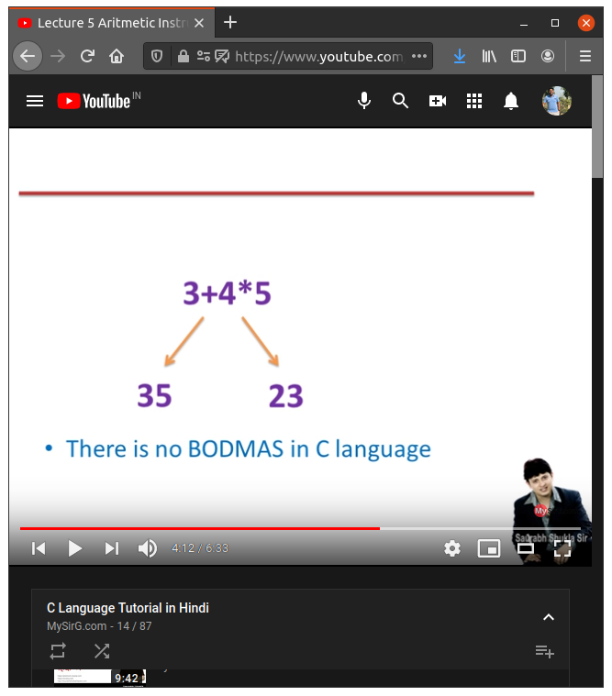  
  
  
  
Notes:- All the operator are assign in serial wise so, we can learn the operator line by line.  
  
(1) unary operator

1. Arithmetic operator
2. Bitwise operator
3. Relation operator
4. Logical operator
5. Conditional operator
6. Assignment operators

Unary operator   
  
increment operator  
  
x++; post increment (x=x+1)  
++x; pre increment (x=x+1)  
  
when we want to increase 1 value (add) in the value of any variable, so we can use this program:-

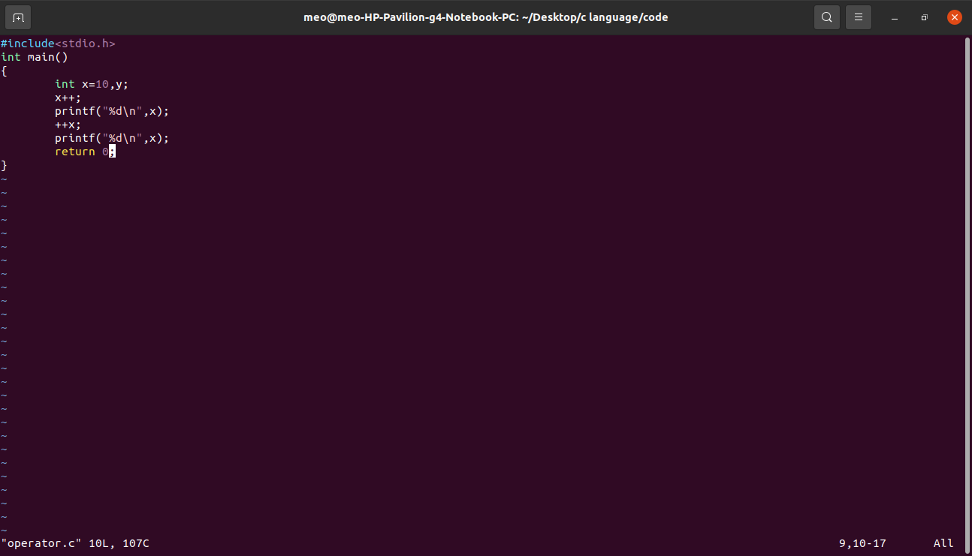  
  
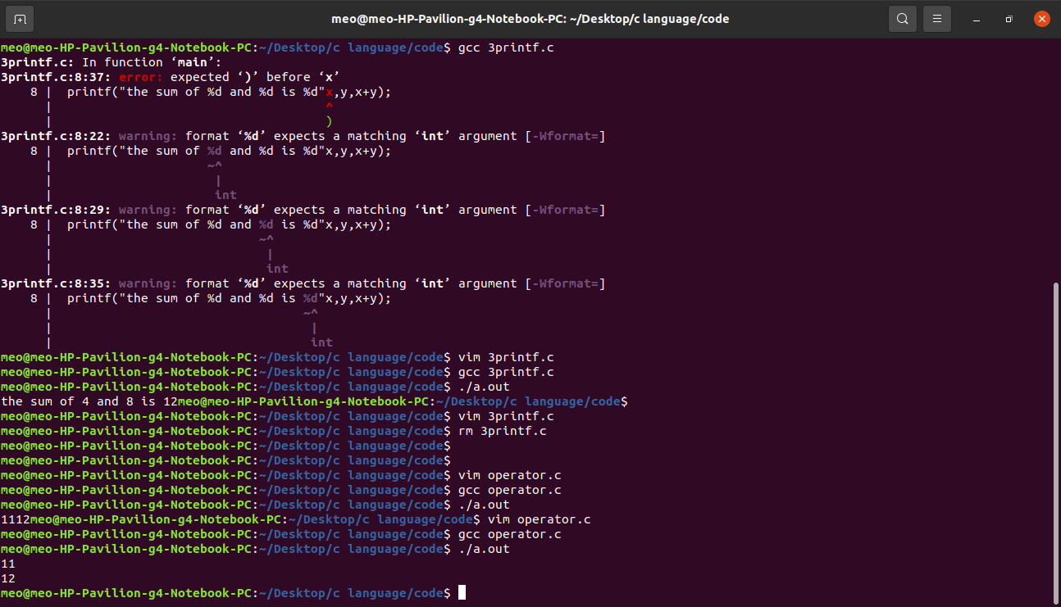

Decrements operator  
  
  
x--; post decrement (x=x-1)

--x; pre decrement (x=x-1)  
  
when we want to decrease 1 value(subtract) in the value of any variable, so we can use this program:-

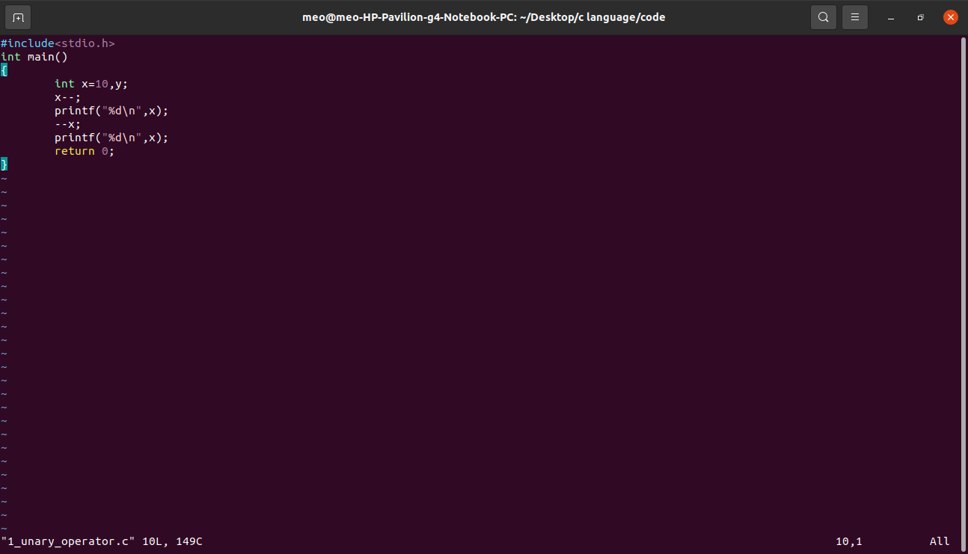  
  
Result  
  
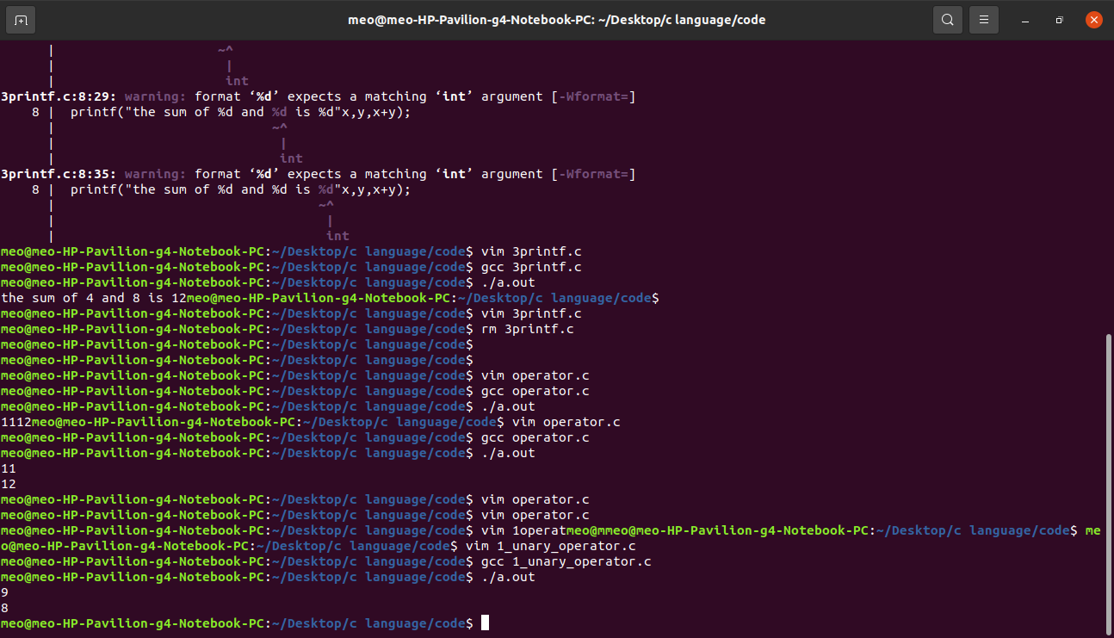

When we use two post operator to make the program:-

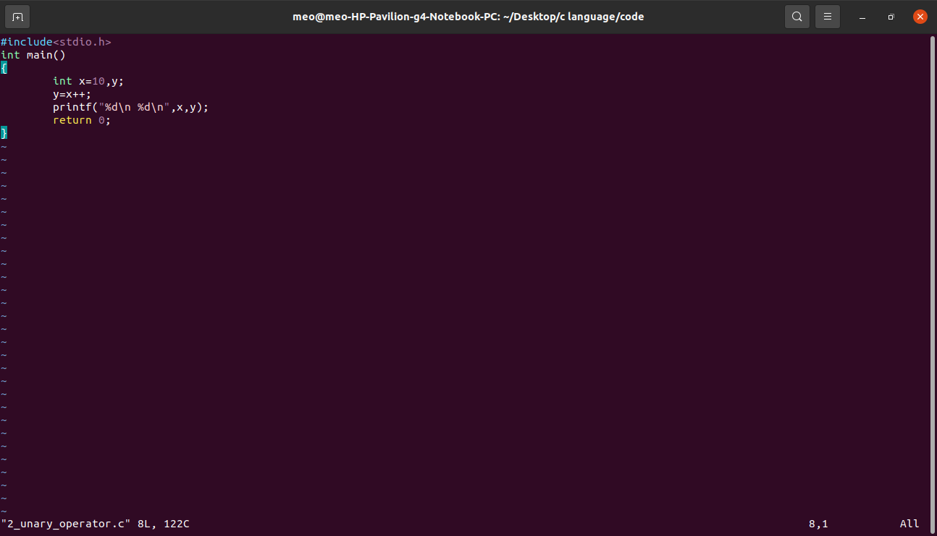  
  
result   
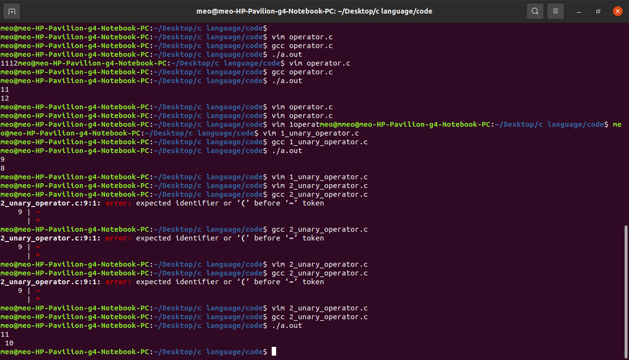  
  
when we use two pre operator to make program :-

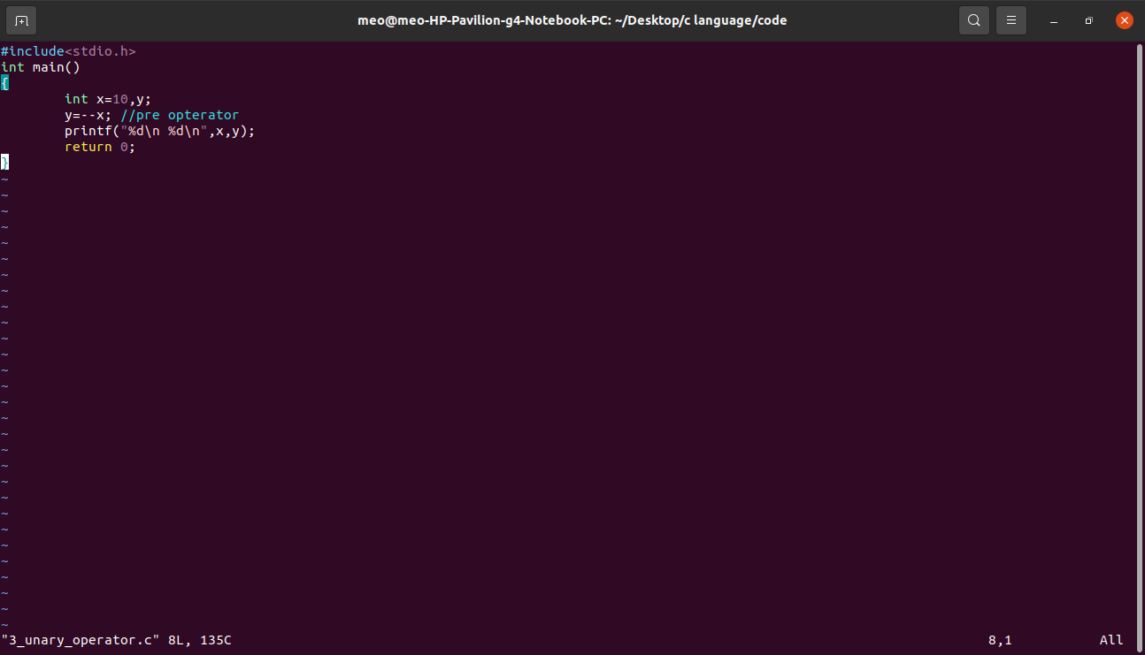  
  
Result  
  
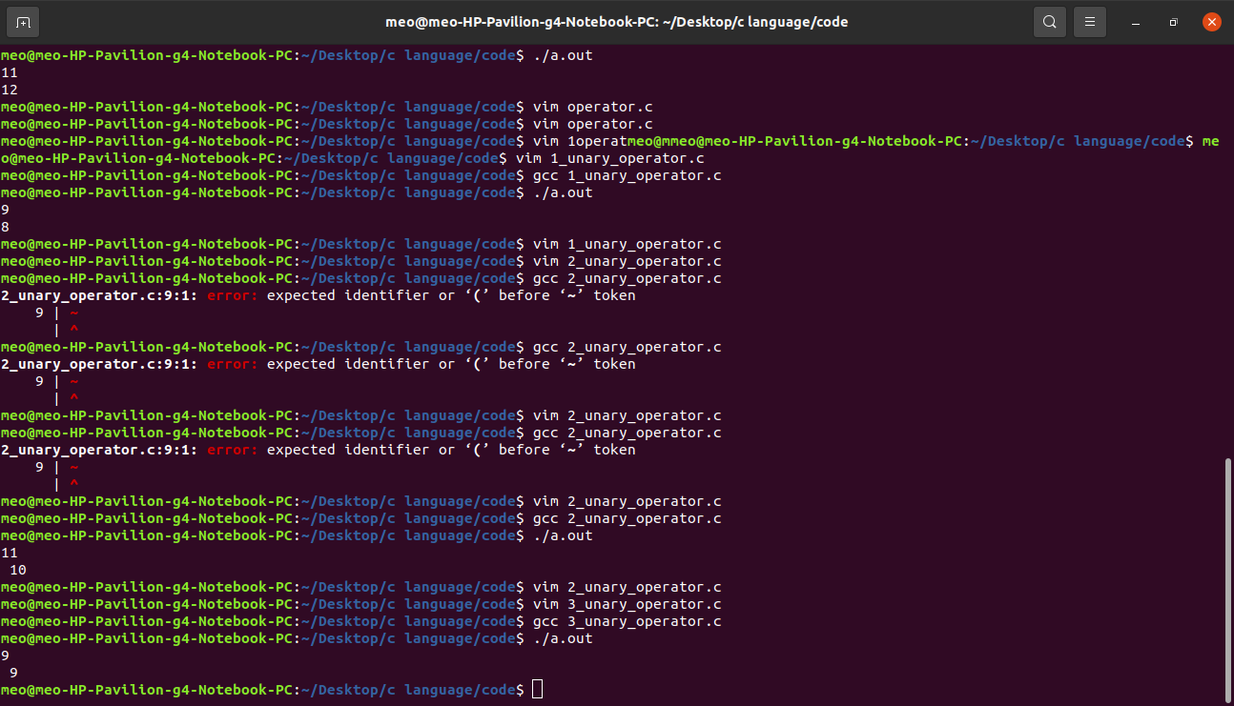  
  
sizeof()  
  
sizeof(data type)  
sizeof(variable)  
sizeof(constant)

NOTE:- i use 64 bit architecture  
  
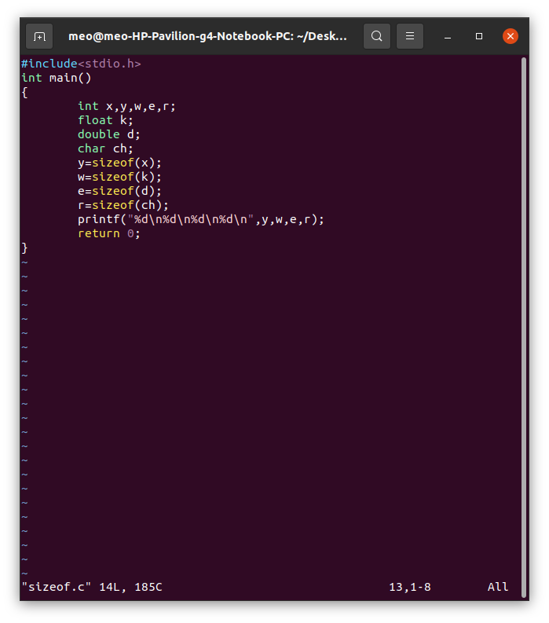  
  
Result  
  
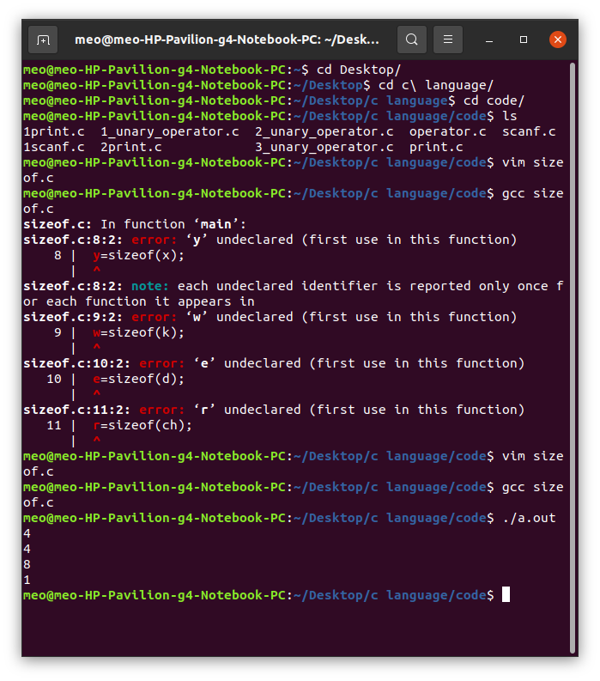  
  
  
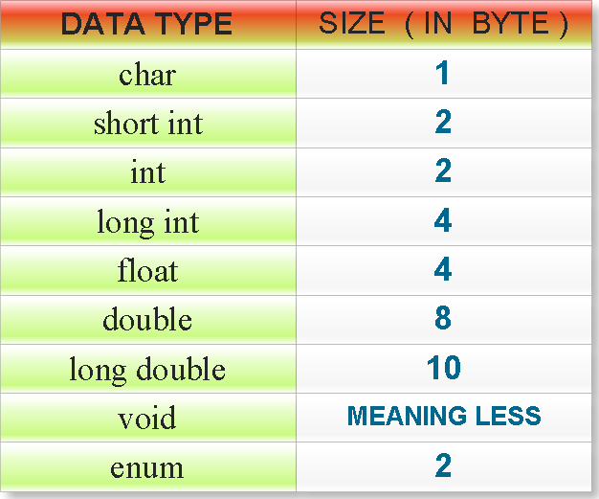  
  
  
sizeof are use to find out the bit architecture in data type.  
  
  
Modulus operator (%)   
  
  
  
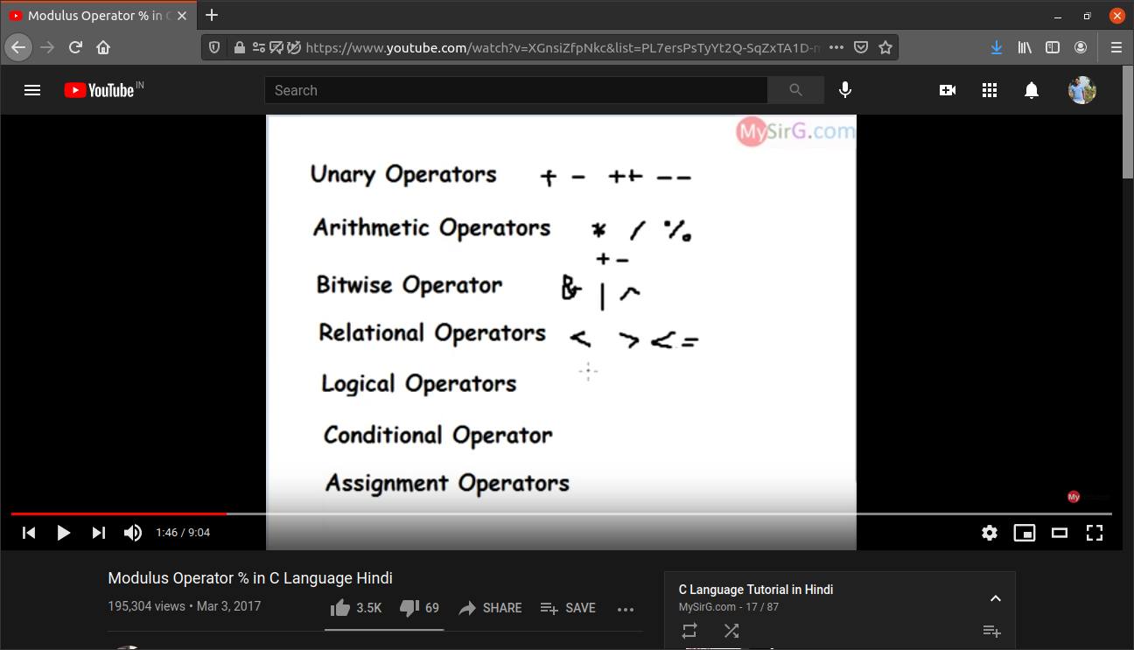  
  
  
Arithmetic Operator are use in multiple or divide that arithmetic operators priority is max but small the unary operators.  
  
  
When we want to show the remainder any number so we can use this (%) symbol not this (/).

Then your numerator is neg so your ans is also in neg and we also ignore denominator.  
  
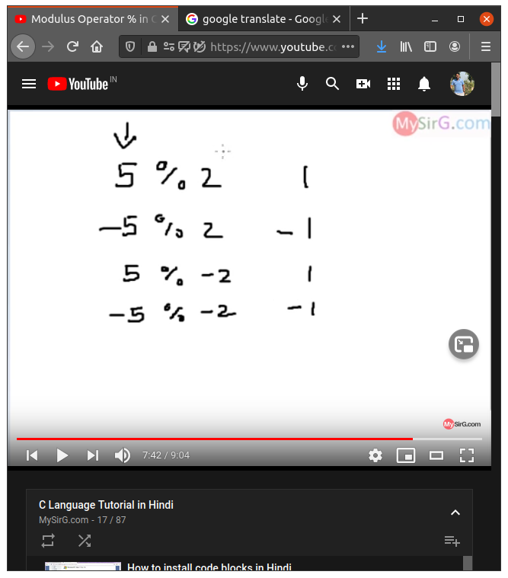  
  
  
  
  
Arithmetic Operator  
  
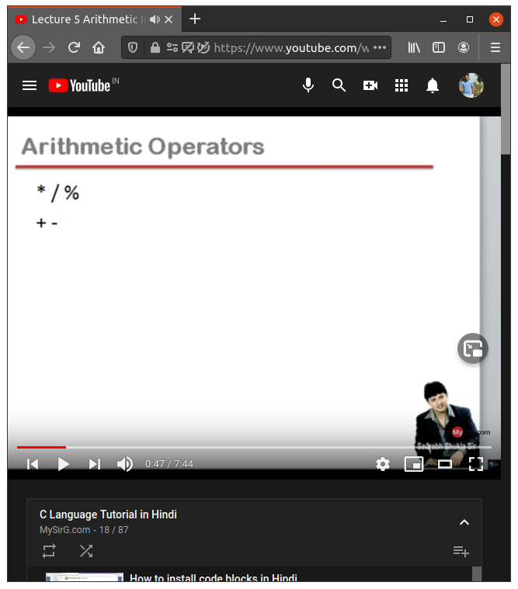  
  
wright *,/,% because the there operation priority is great then + - operation

when we can solve there problem so, firstly we solve *,/,% then we can solve +,-.  
  
associativity rule (start solve in which direction ) L to R..  
  
  
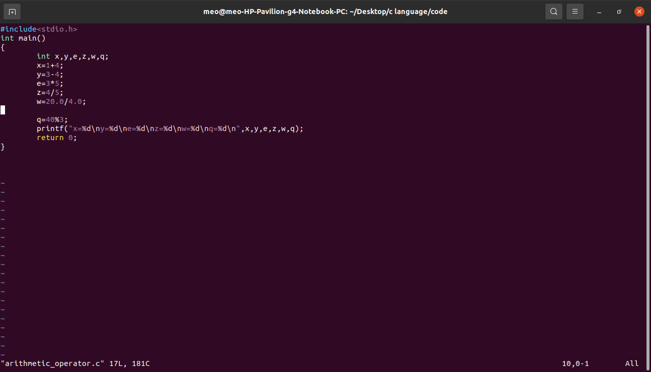   
  
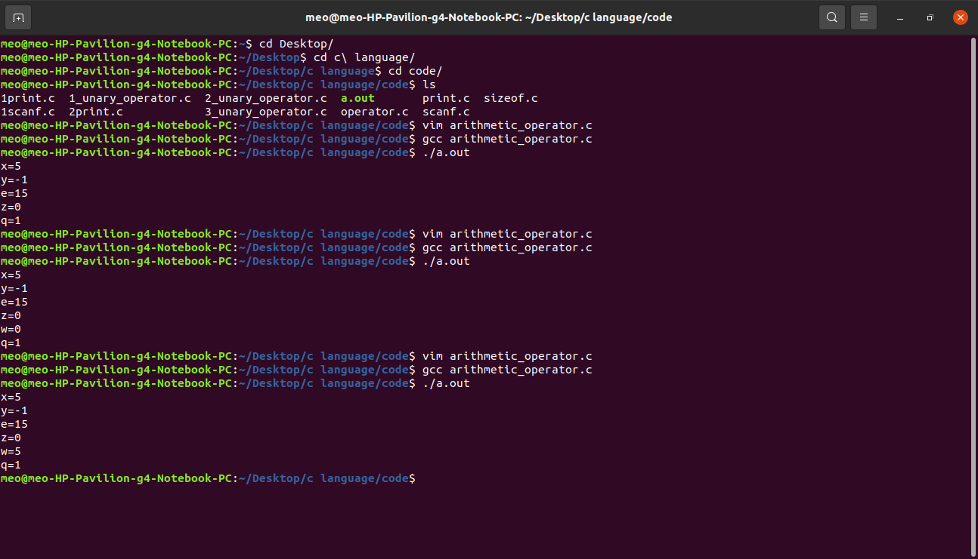  
  
  
when we want to divide and i want answer in point (.) so, we can do input to the user in point mean in real value not in Integer value then use you show that your value is come accurate value in point(.).  
  
***Bitwise not operator***  
  
Bitwise operator is convert 0 in 1 or 1 in 0 that on the basic of 16,32,64 bit architecture.  
  
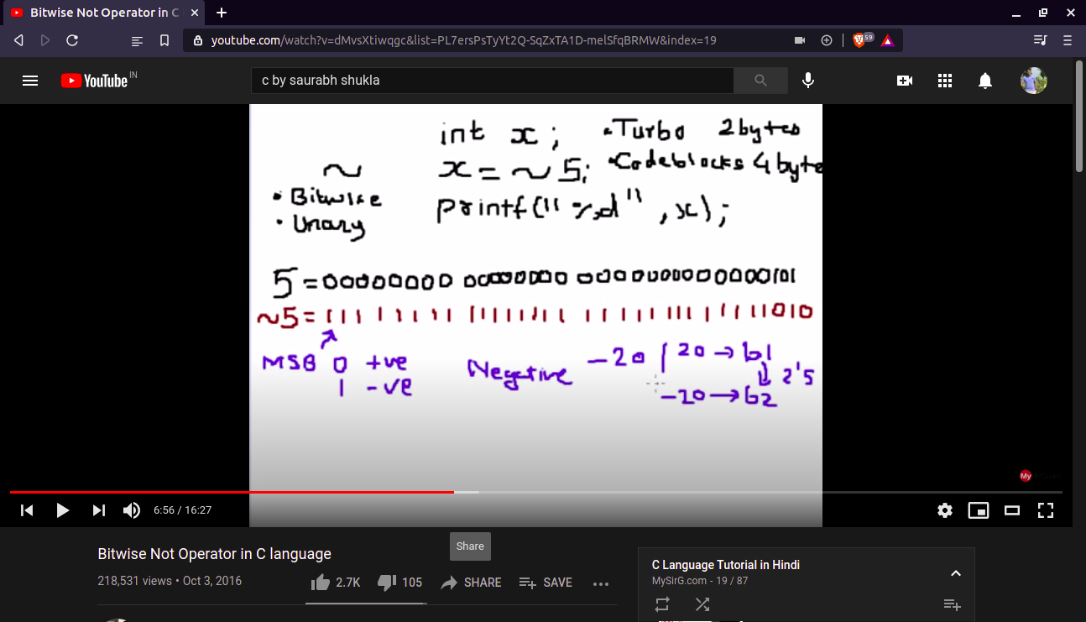  
  
  
Bitwise AND operator   
  
  
  
bitwise operator are use to convert o or 1 that it have following a rule.   
  
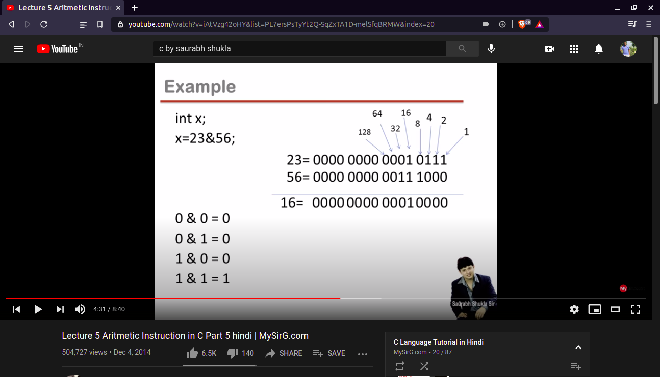

***Bitwise OR operator***:-

Bitwise OR operator is also convert the 0 or 1 but in there own following condition.

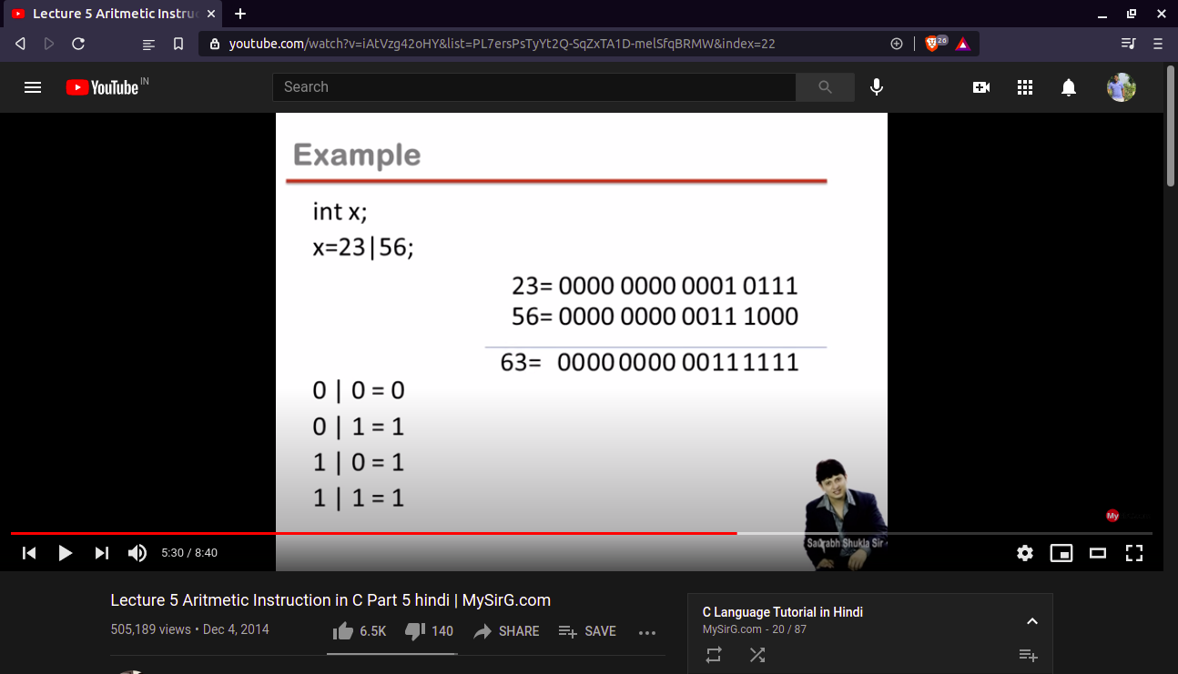  
  
***Bitwise XOR operator***  
  
  
bitwise XOR operator is also use to convert 0 or 1 but there also following condition.

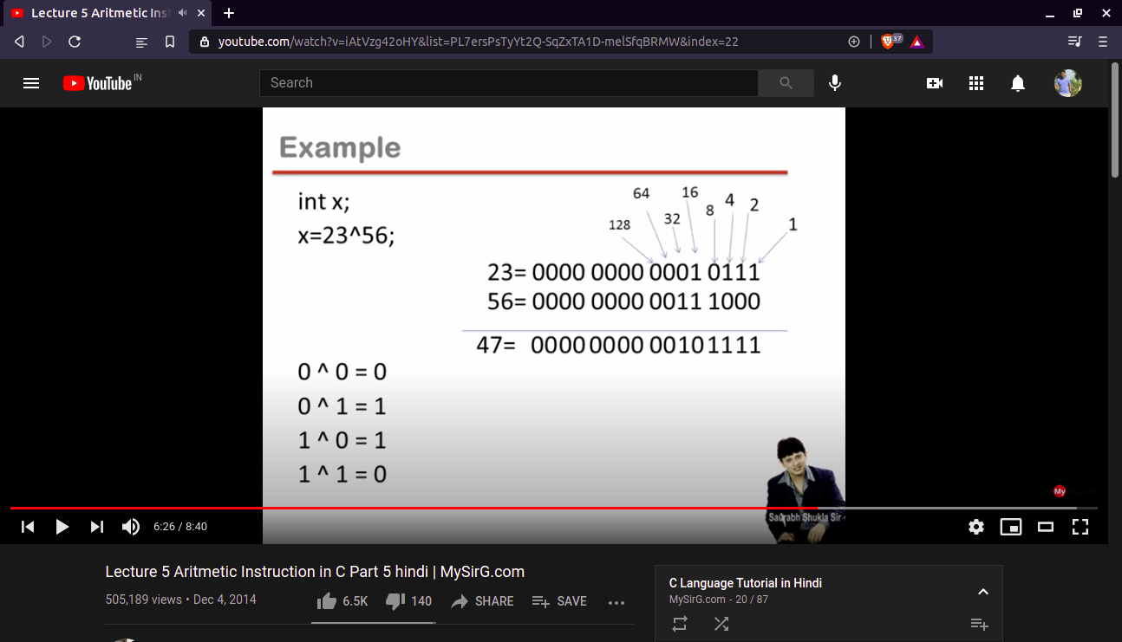  
  
  
***Right Shift***   
  
  
right shift operator mean two zero are applied in front of there binary number but we also remove two number from back.

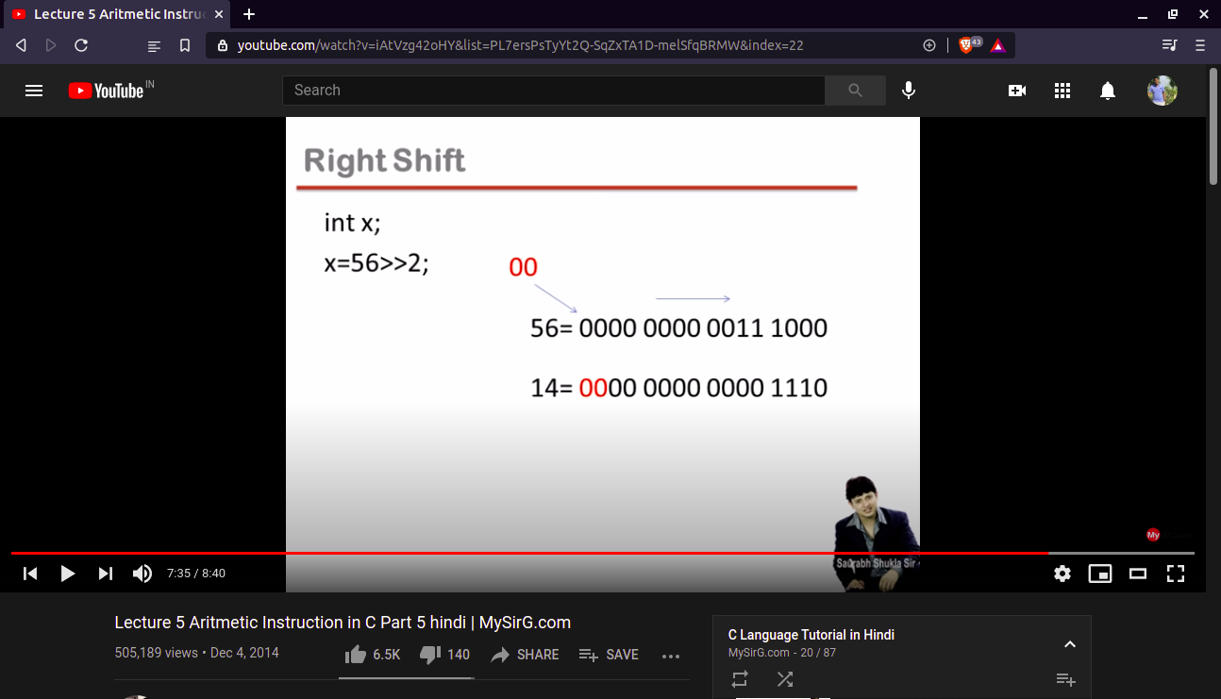

***Left Shift***

Left shift is almost same to the right shift that three zero are applied in the back or binary number and remove there number in front.

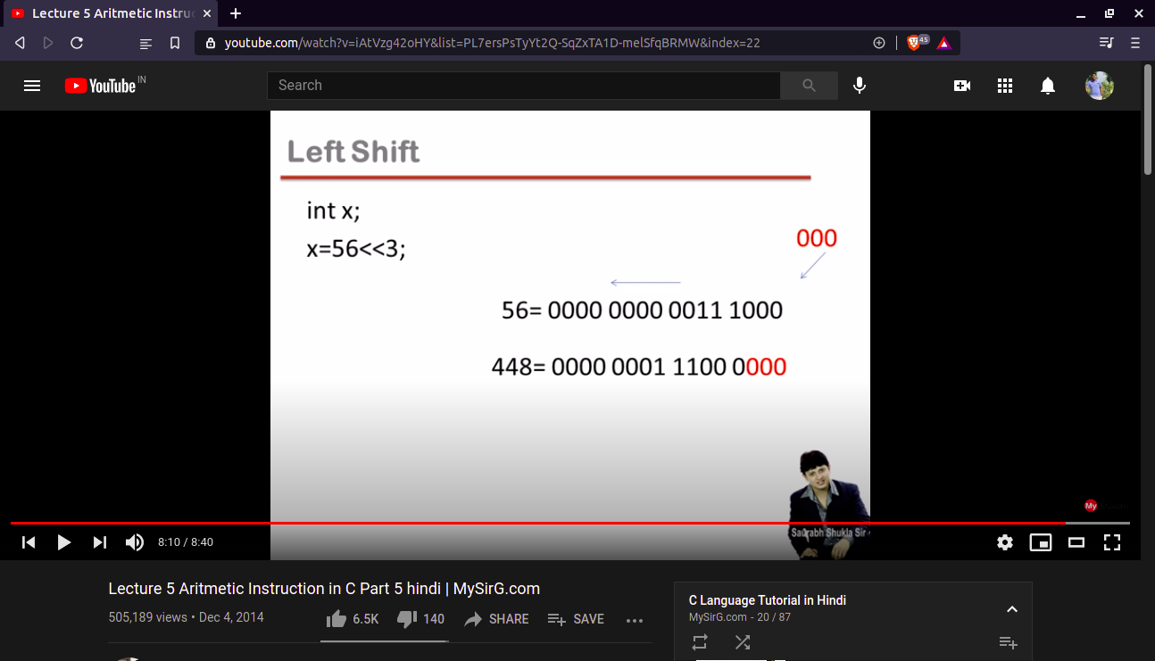  
  
  
  
***NOTE***:- there all binary number in 16 bit architecture.

***Relation operator***  
  
1> relation operator result is always in 0 or 1.  
2> every non-zero value is true and zero is false.

1. True is 1 and false is 0.  
     
   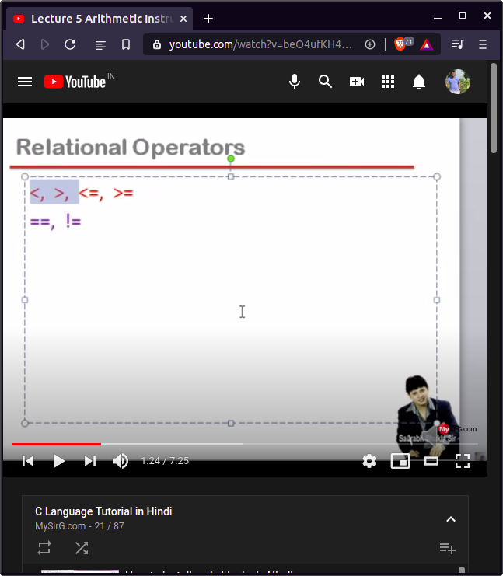  
     
     
   all the upper side operator are solved first then we solved lower one.

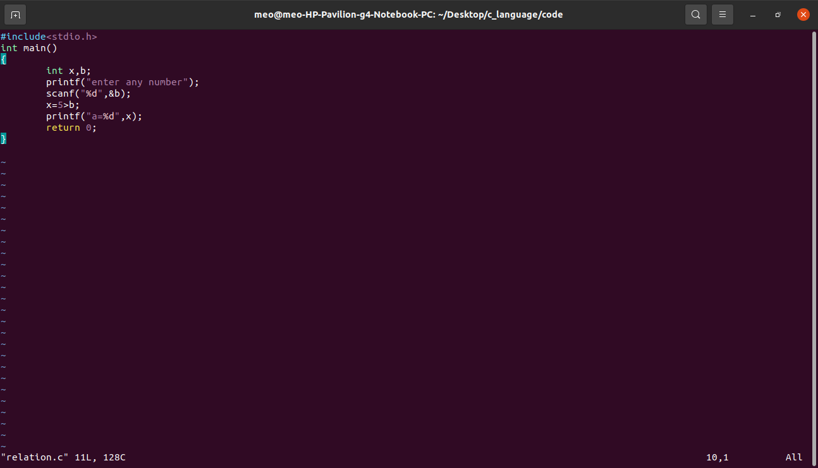

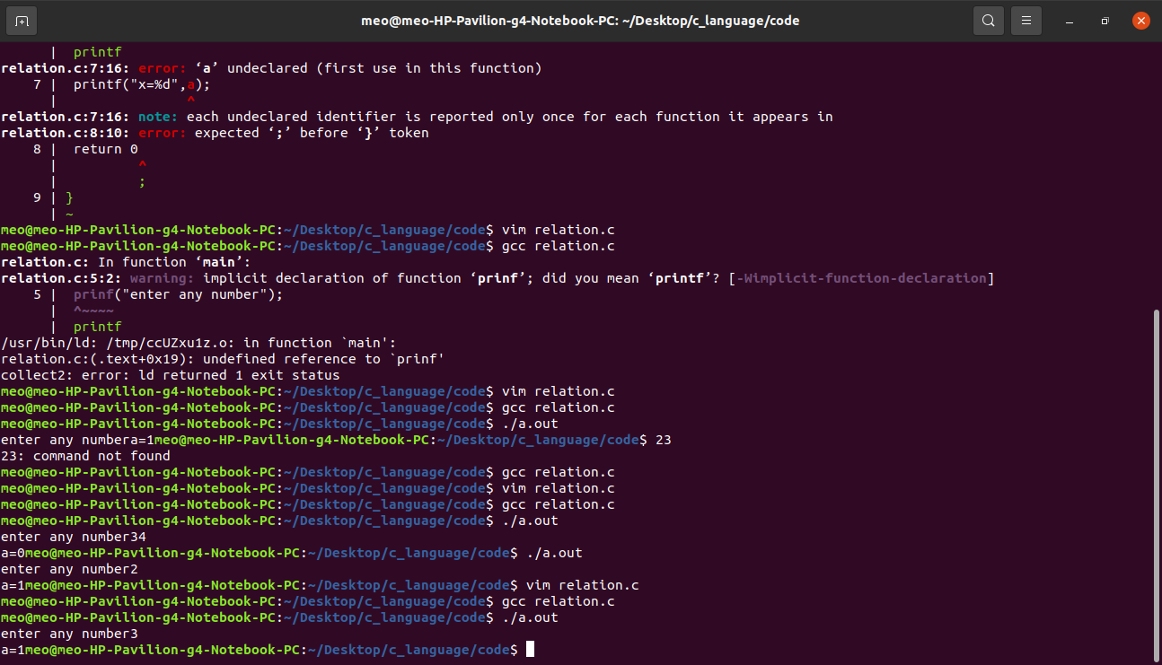

Dekho ye wala program ma humna 34>b sa or jab bhi hum koi bhi input daga or wo b is store ho jaya ga or fir ye check kaya ga ke ye condition true ha ke nahe agar ye wale condition true ho ge to 34>b ke jagah 0 ye 1 aa jaye ga aur fir ye check kaye ga ke (0 or 1)>0 ha ke nahe agar condition true hoge to ye 1 output daga or agar ye condition false ho ge to 0 output ga da.  
  
  
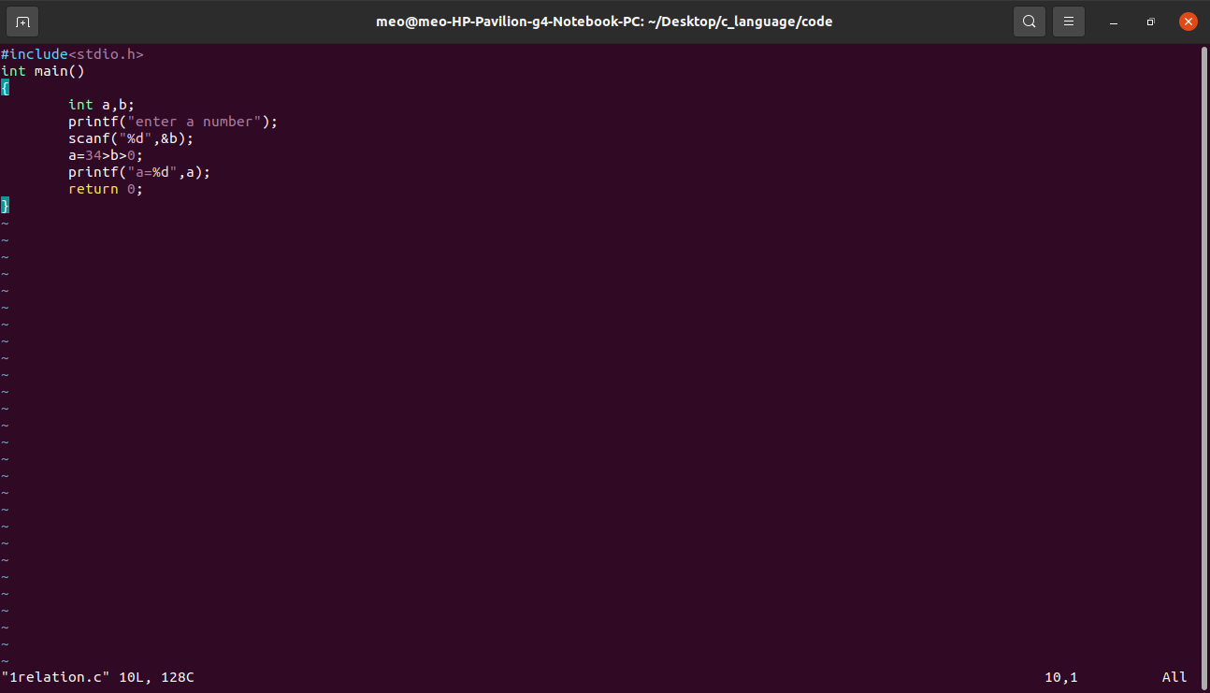

There are two input possible value:-

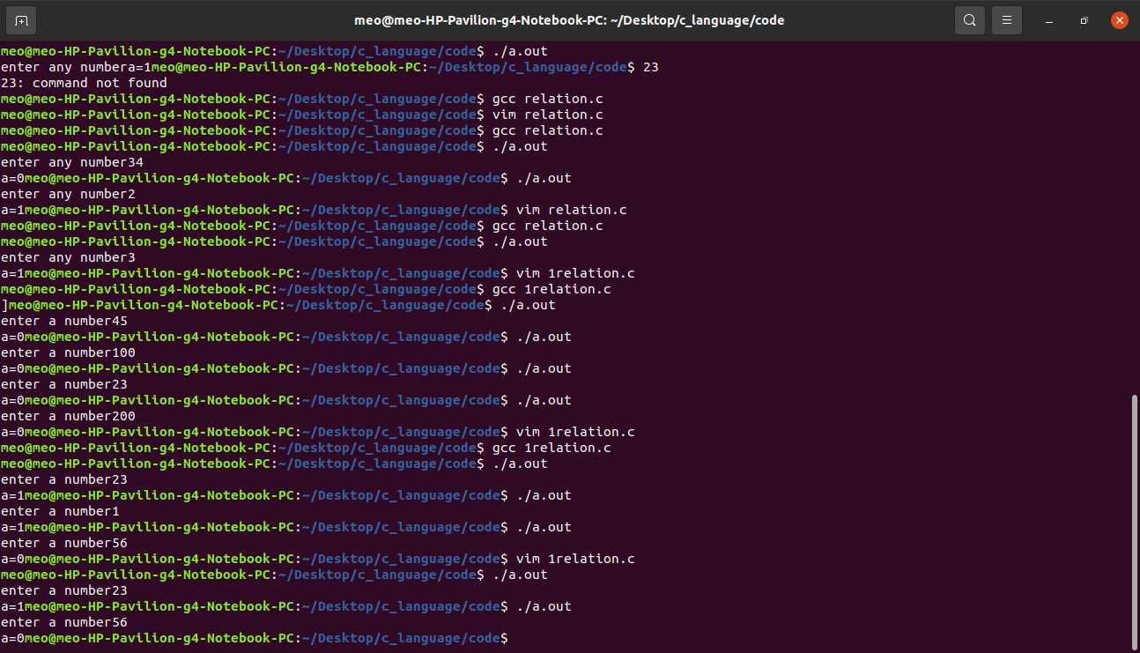  
  
*Logical operators*

There are 3 type of logical operator:-

1. ***Not*** !
2. ***And*** &&
3. **Or** ||

NOT(!) operator are use to inverts the value of there statement.

It is also unary operator.

!T = F

!F = T

***AND(&&)***

AND(&&) operator need 2 oparent

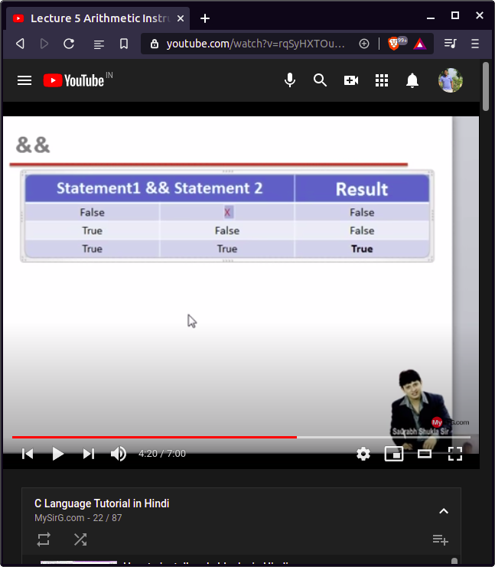

Agar statement1 is false hai to hum log statement2 check nahe kaye ga ye fir agar statement1 is true hai to hum statement2 ko check kaye agar statement2 false huya to result false ha ga or agar true hoge to fir result true ho ge.

***OR ||***

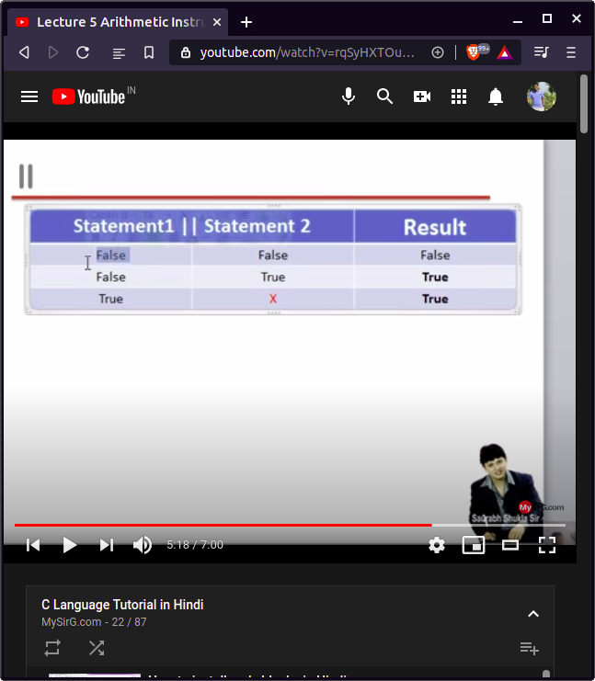

Agar dono statement ma koi bhi ek bhi true hai to fir result true hoga.

***Condition operator***

Condition operator is make up of ? and :  
  
In there operator has a 3 condition that 1 condition is check and if 1 condition is true so 2 condition run but if 1 condition is false so,it run 3 condition.  
  
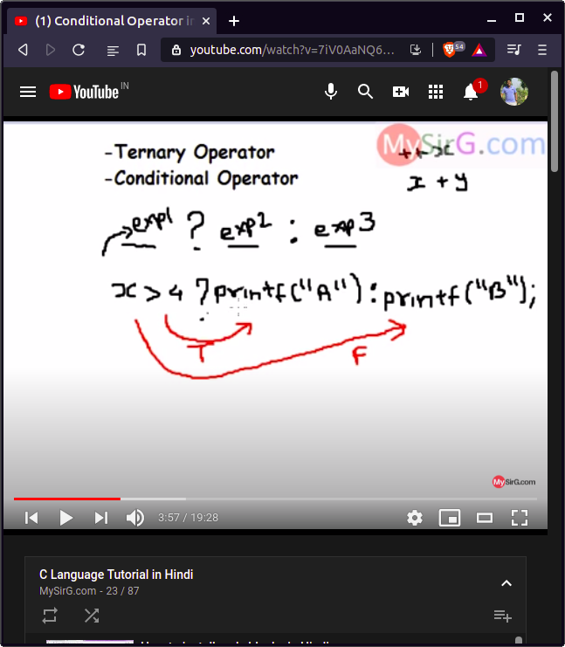

Condition operator program.

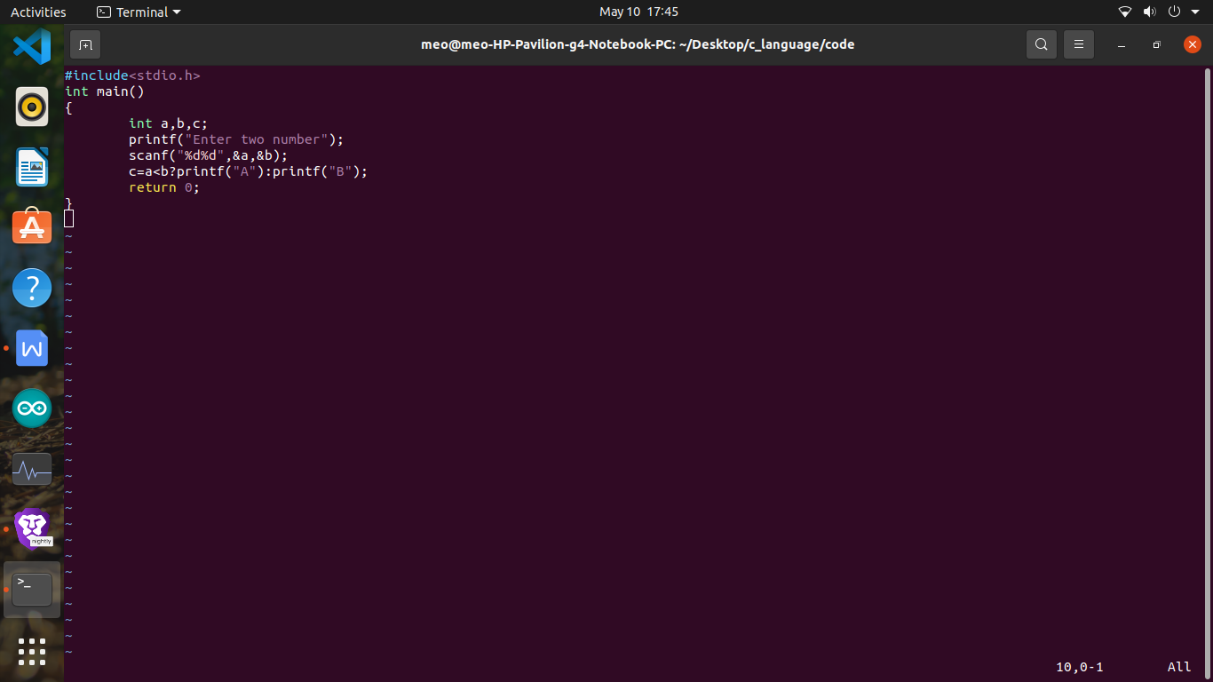  
  
  
***Control***   
  
when we compile the code, the code is running line by line and when any line have error so, he showing error and code is do not run that mean in c language using compile and interpater.

Type of control instructions  
  
(1) decision control instruction

1. Iterative control instruction
2. Switch case control instruction
3. Goto control instruction

Decision control instruction   
in this control instruction we use

1. If // we already known what is if and if-else so, we skip this.
2. If-else
3. Condition operator or ternary operator(?:)

Condition operator is already use but we also make a anyother program for batter explain..

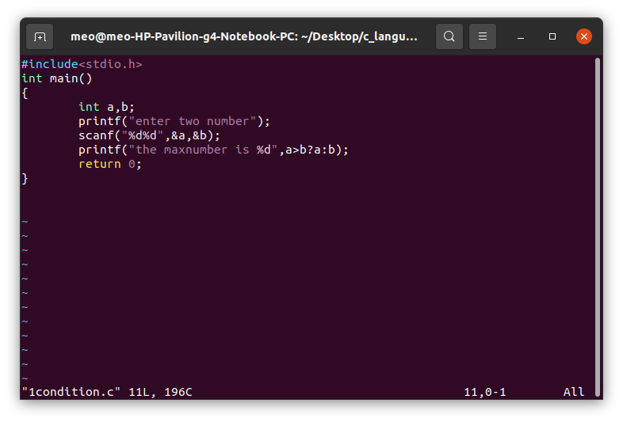

Nested If-else

Nested if-else mean we use multiplay time if and else in same code

